# 听力

听到不懂得地方就听读，一周测试一次。默写听力常用词汇。

# speaking

1．选一个主题，即兴说2分钟，想到什么说什么，不断过3秒，不重复。

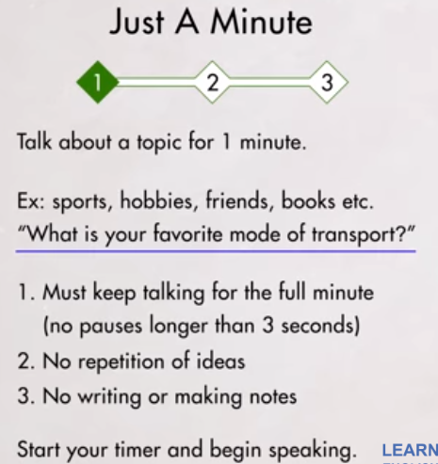

2．写几个相关的主题，按主题说2分钟，不断过3秒，不重复。

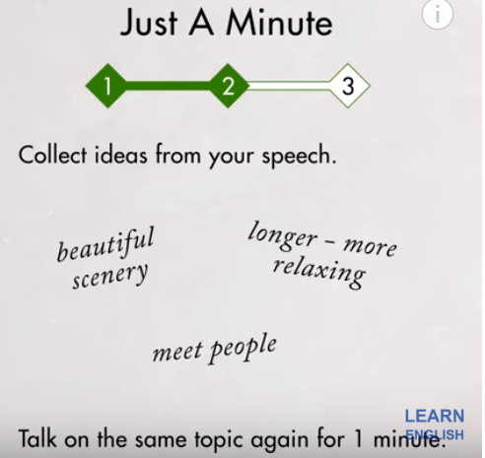

3．给出所有句子，说出来并录音，纠正自己的发音。

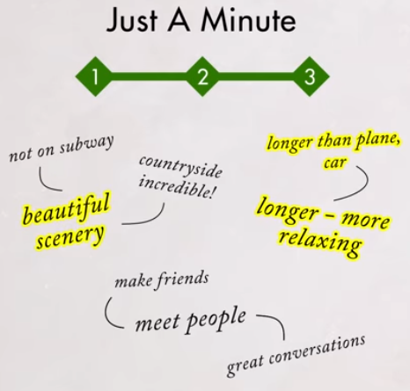

## list of headings

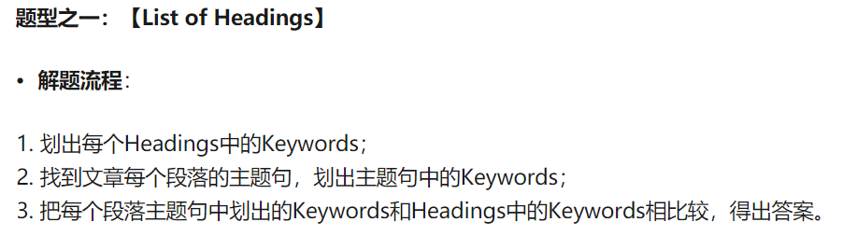

找keywords的方法

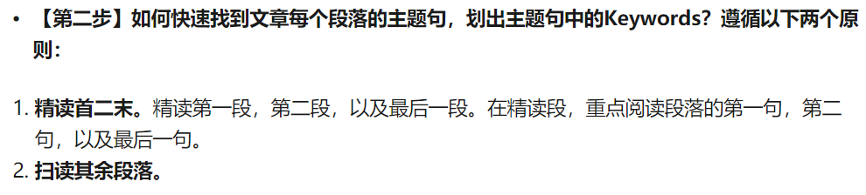

比对方法



## TFNG，YNNG

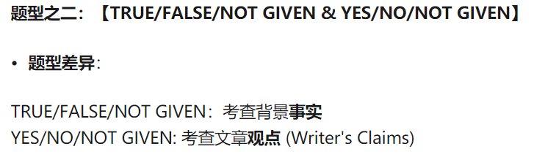

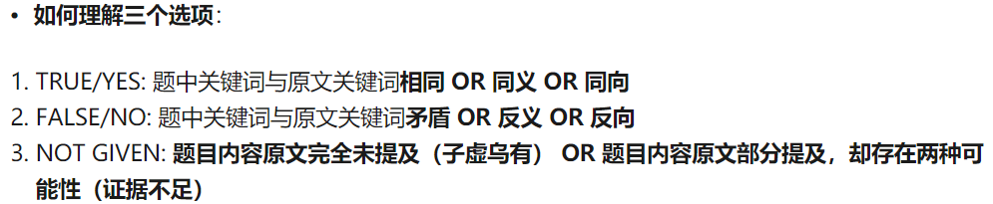

仔细理解答案的意思

连看2个答案，利用答案中的主语进行定位

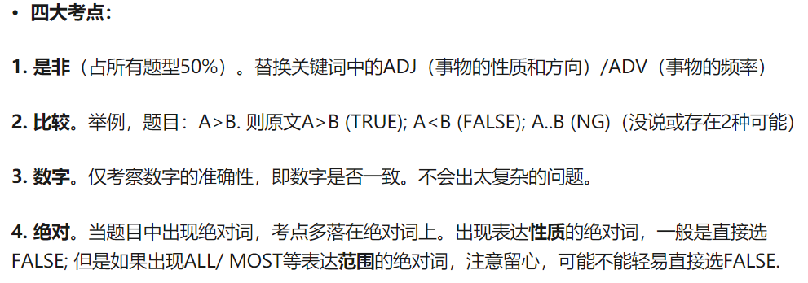

FASLE：仔细理解答案，答案的相反意思包括原文

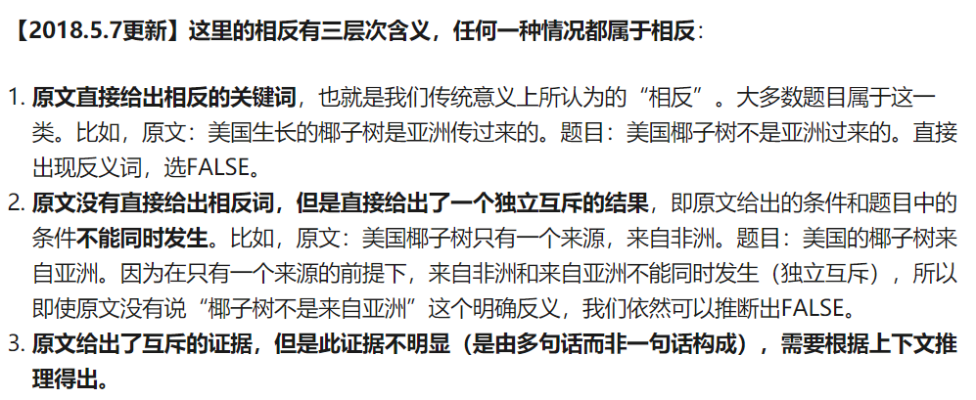

## Matching

重点首二尾，读是标人名，时间，key。读完习惯性总结下。

## 365天常用口语

### 起床

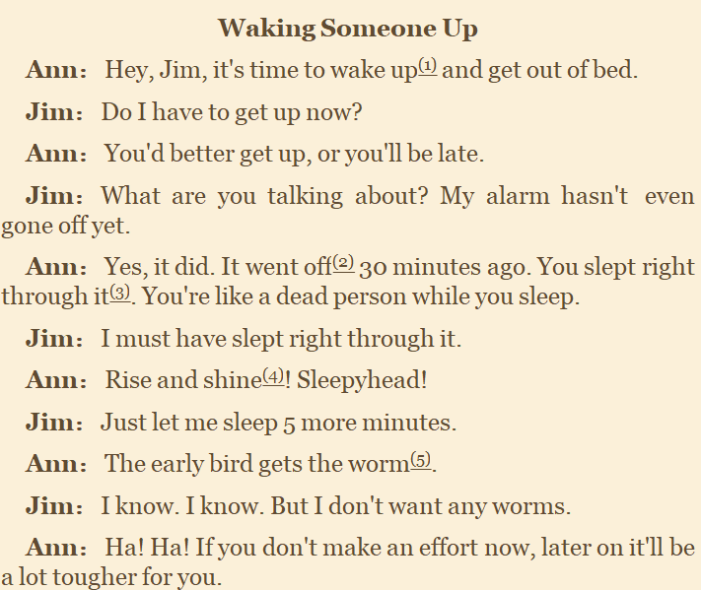

### 睡觉

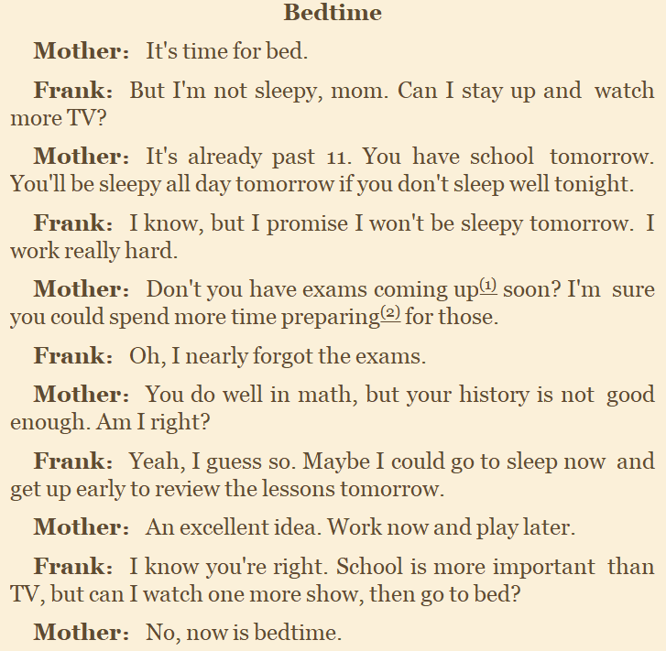

### 公寓

It’s not really all that good

it should be enough for our needs

we’d never be able to fit all our stuff in there

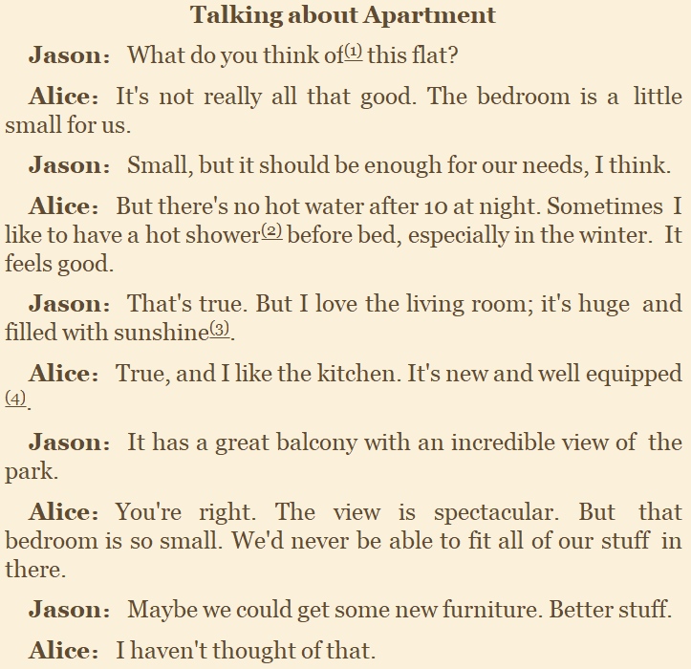

### 离家前

way are you so dressed up

I’m on my way out to a , the one you have on

missing out on a good time, Do you have any idea

I’d say

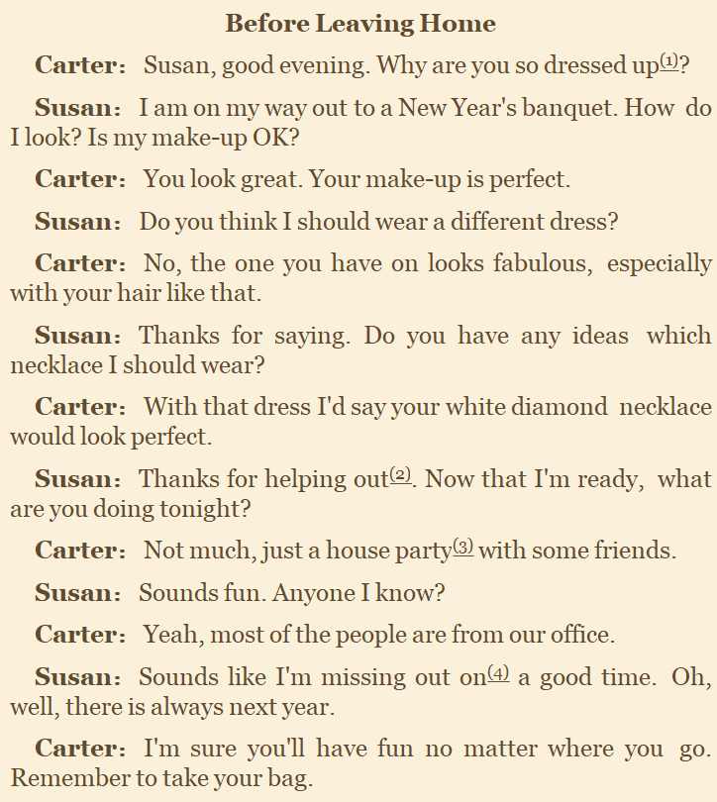

### 回家后

He gives far too much homework all that much

you should’t say anything at all

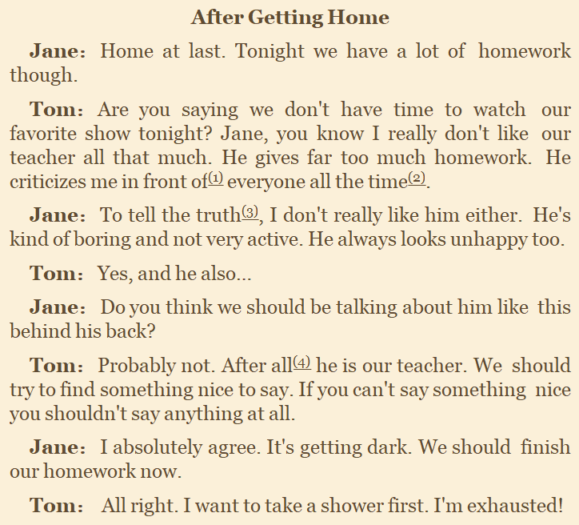

### 做饭

I’d like to pitch in with

how can i help I guess A it not as easy as I though

I could do that with take a look at that

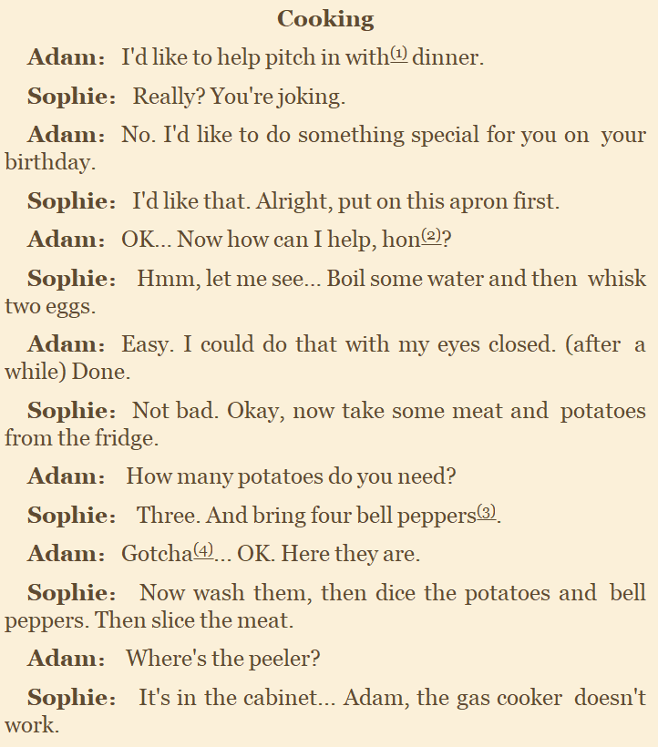

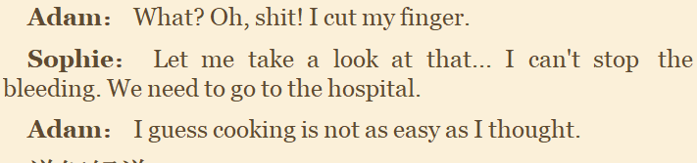

### 吃饭

I haven’t seen you in ages how are you getting along take a seat

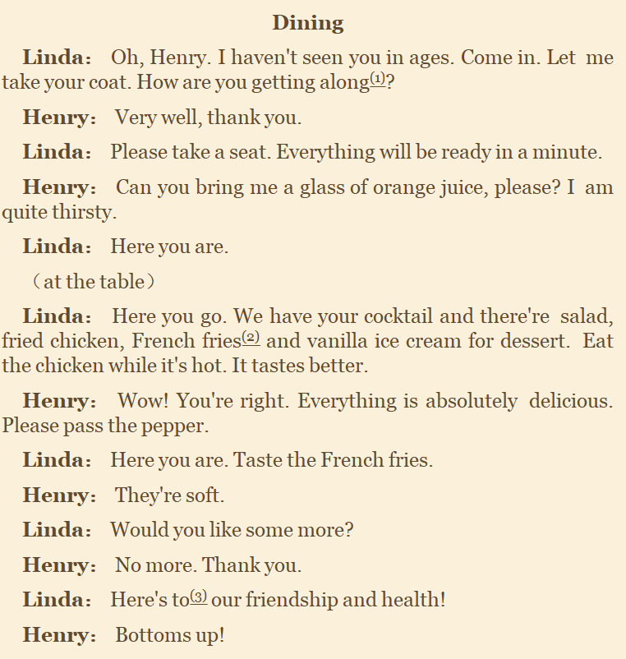

### 饮料

I’ll get ice wll, if you say so I’d rather A than B in the way of A

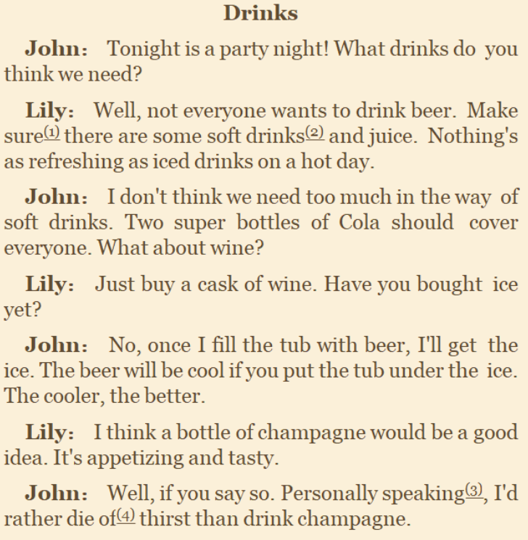

### 肉类

what kinds of have you ever tried I’ve heard that

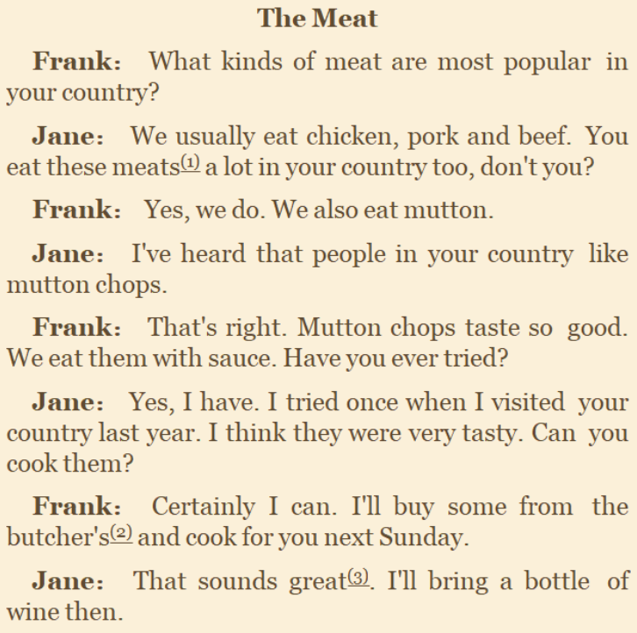

### 早餐

getting ready fried egg sunny-side up



### 收拾碗筷

suppose you have to do one of the two。 cleaning up。The way i see it，will you do

doing either one

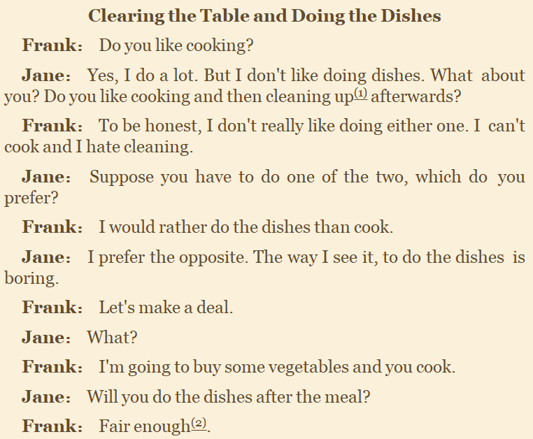

### 开销

running out of A，handle A better，was kind of，don’t have to ，in case of，

have more selfcontrol，what things did you spend you A on，let bygones be by gone

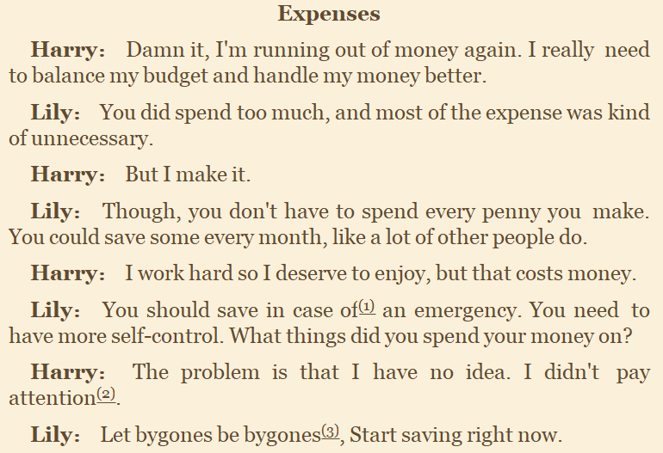

### 储蓄

A is so far off in the feature，right up until，I never thought about it that way

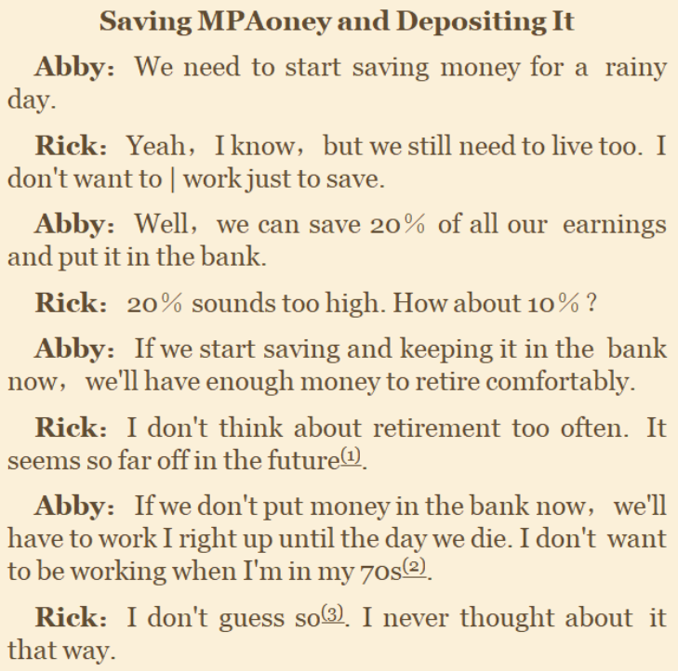

### 接电话

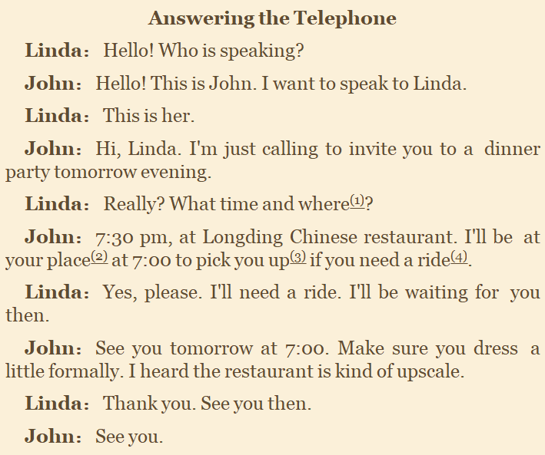

### 打电话

you line was busy，Is there any other way，gone out of，away for several days

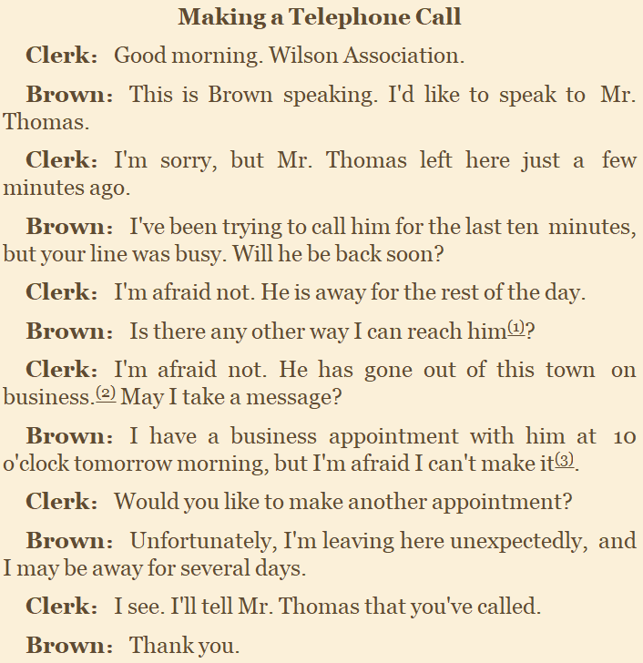

### 电话留言

when do you expect him back，if you’d like，he will get back to you，

I need him to call me back



## 剧

日常：摩登家庭，老爸老妈浪漫史，伦敦生活。

访谈秀：Ellen show，Conan，james Corden，The Graham Nortor show

神烦警探（警察），实习生风云（医学），硅谷（融资）

UP主：casey neistat，best Dressed

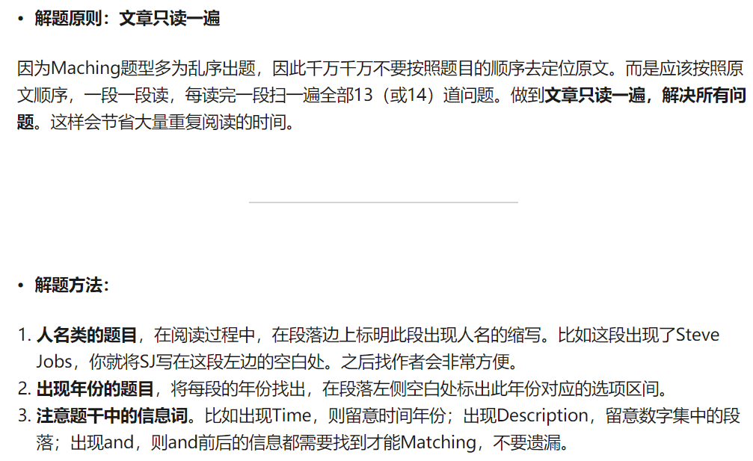

# 阅读

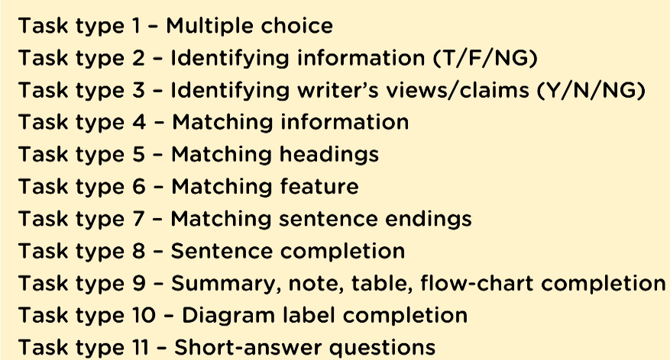

# 写作

## 行文结构

<https://www.ielts-exam.net/ielts_writing_samples_task_2/973/>

1. 用题目的问题引出主题
2. 与主题相关的情况，信息
3. 作者观点以及论据1
4. 论据2
5. 总结并强调观点

## 语法

### 框架

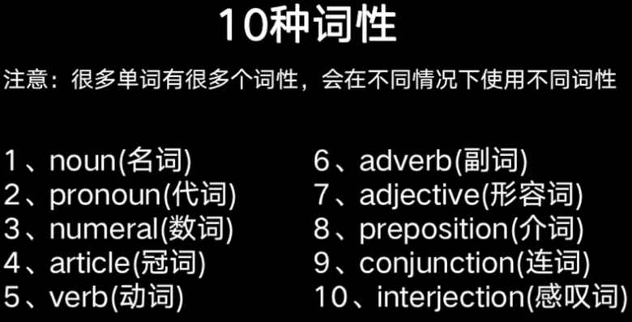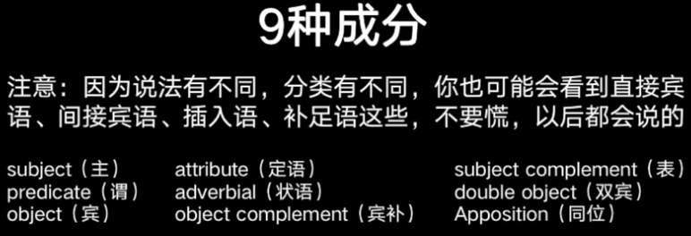

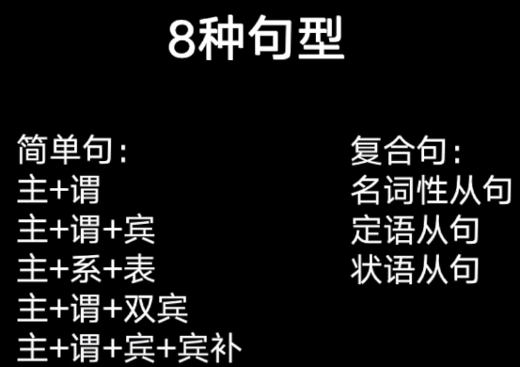

### 简单句

#### 陈述句

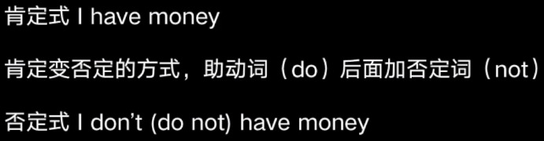

##### 主 谓（描述主的状态or动作）

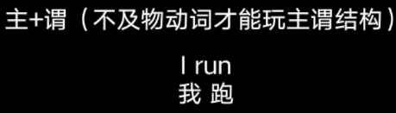

##### 主谓宾

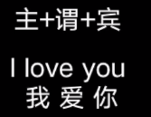

##### 主系表

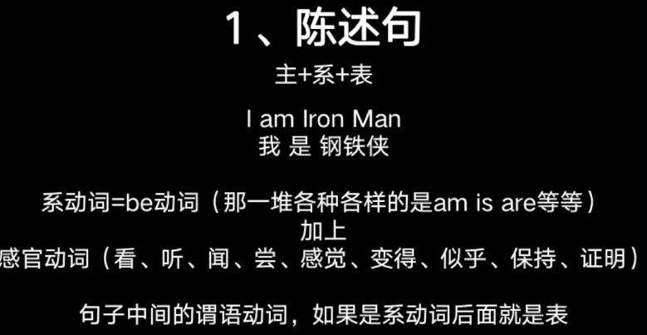

##### 主谓宾宾（动词后加2物）

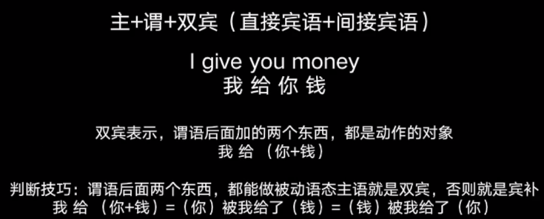

##### 主谓宾补

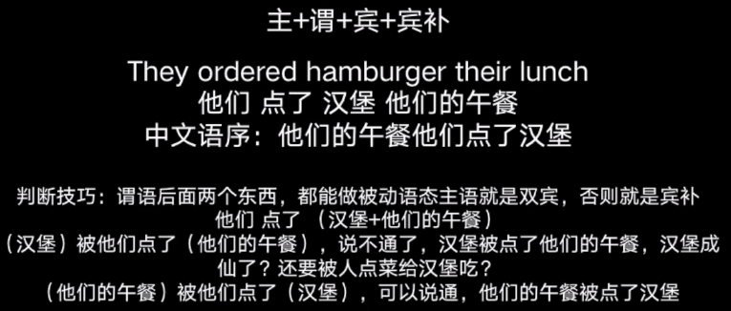

#### 疑问句

##### 一般疑问句

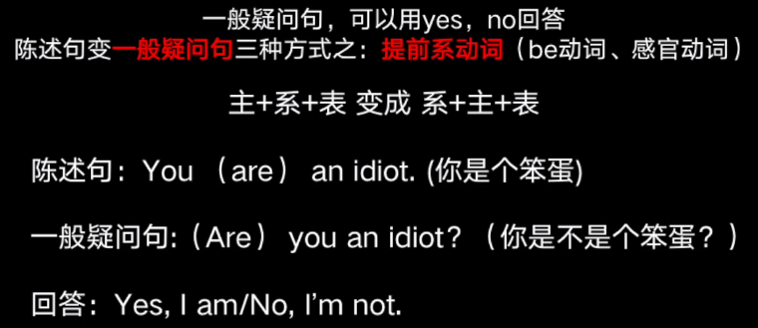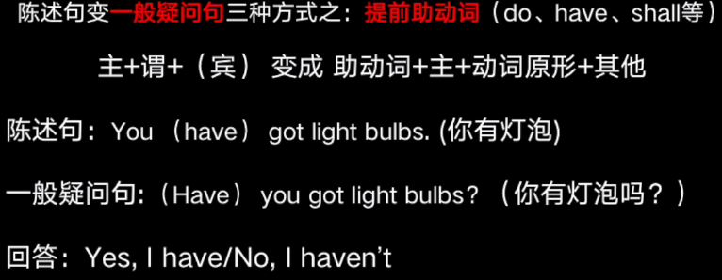

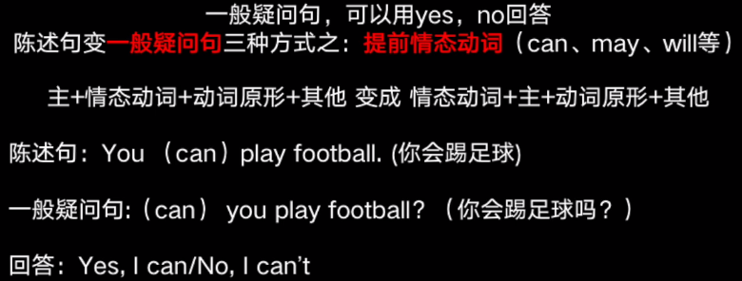

##### 特殊疑问句

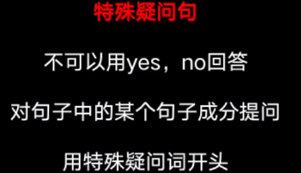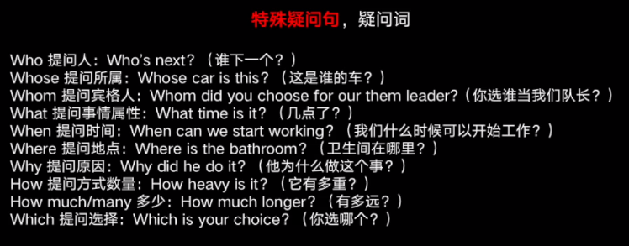

##### 选择疑问句

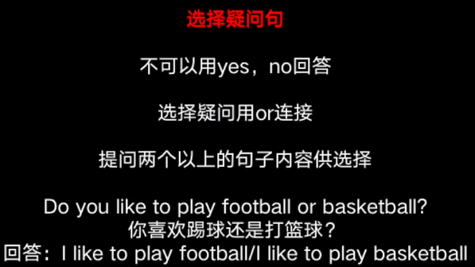

##### 反义疑问句？？？

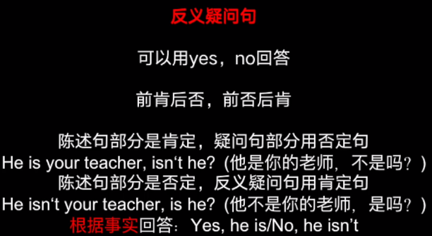

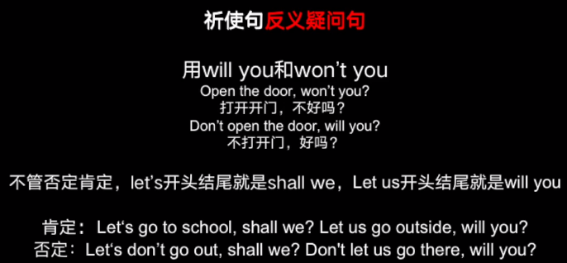

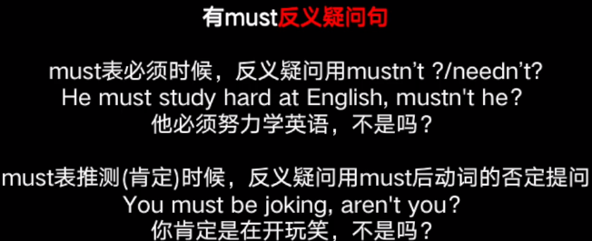

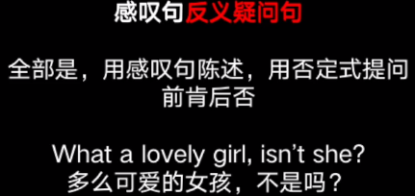

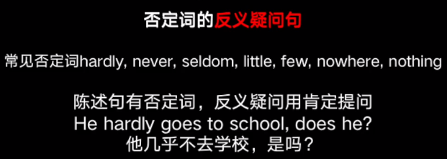

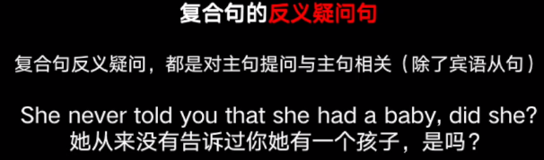

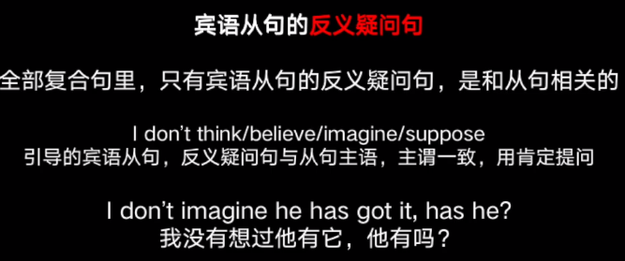

#### 感叹句

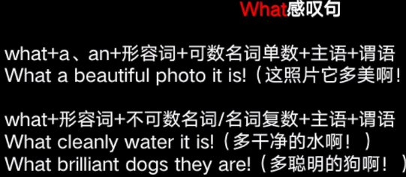

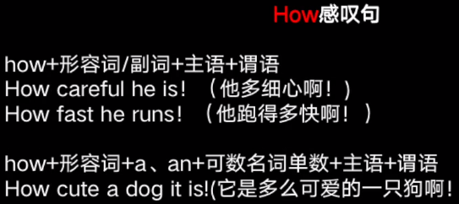

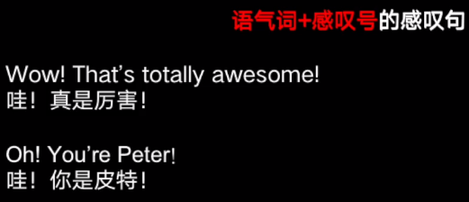

#### 祈使句

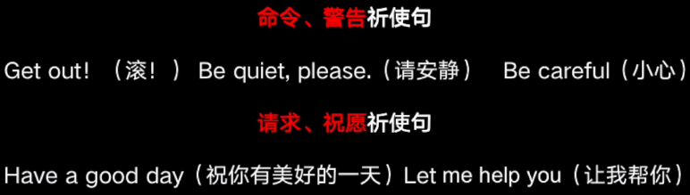

### 10 词性

#### Numeral

##### 基数词

###### 数



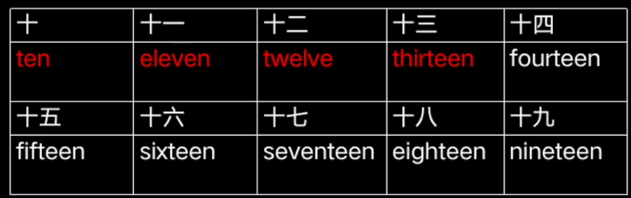

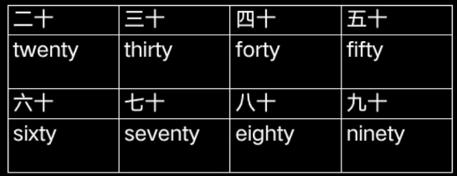

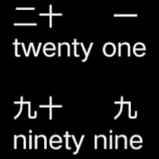

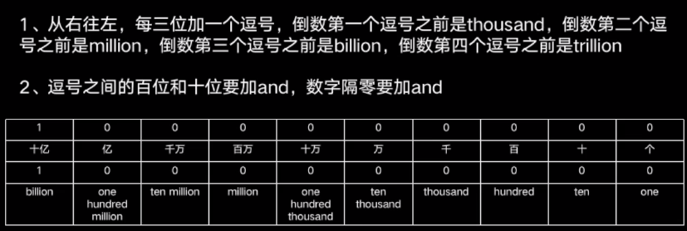

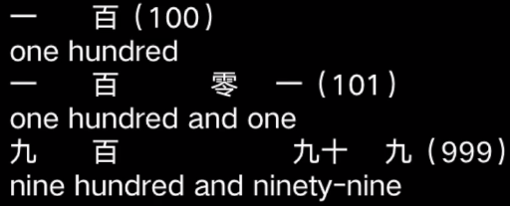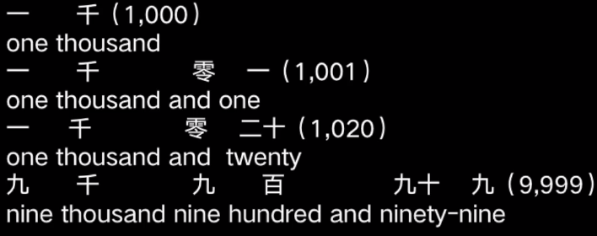

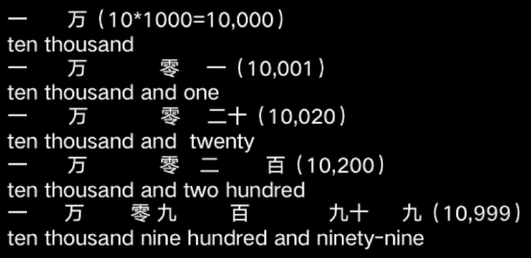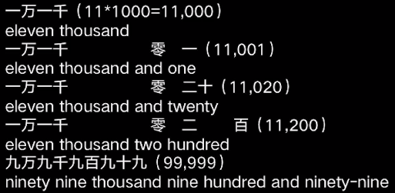

###### 时间

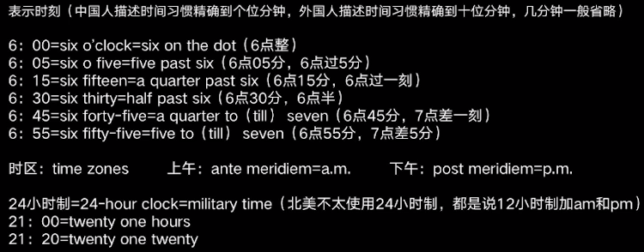

###### 日常读法

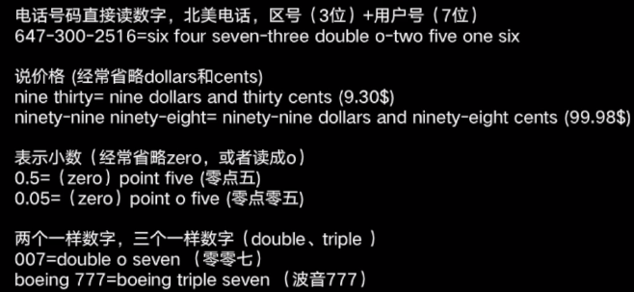

##### 序数词

###### 序



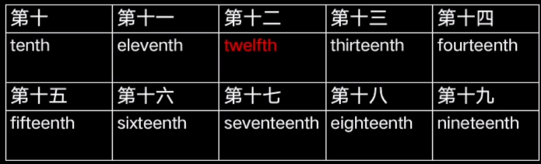

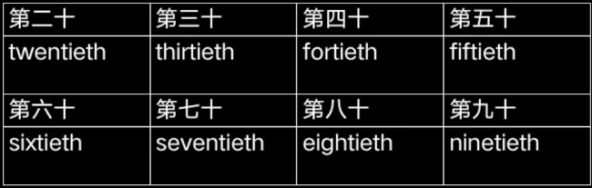

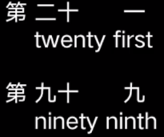

###### 使用特点

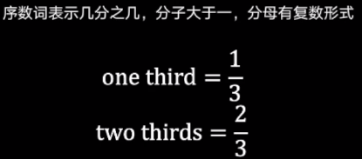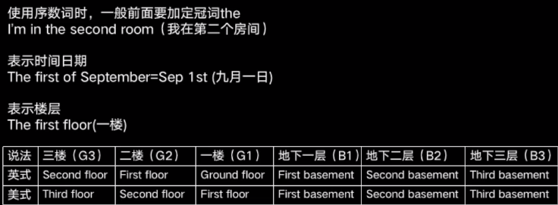

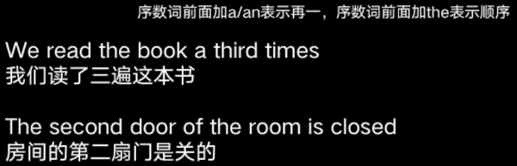

#### Article

##### 不定冠词a an

<http://blog.sina.com.cn/s/blog_4d5d13e20100va2j.html>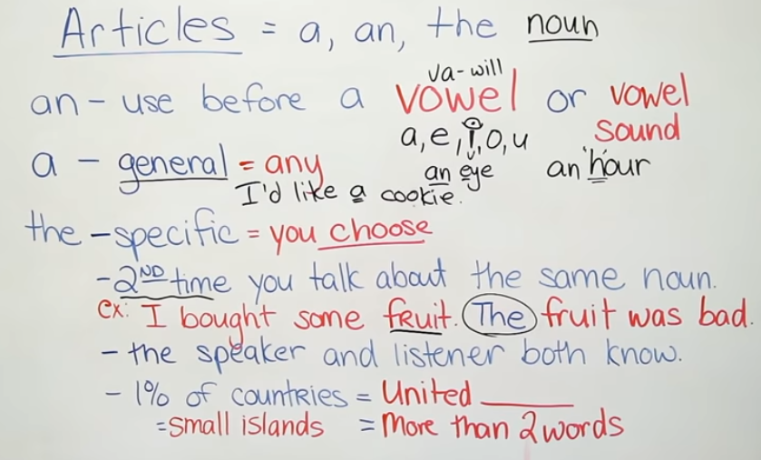

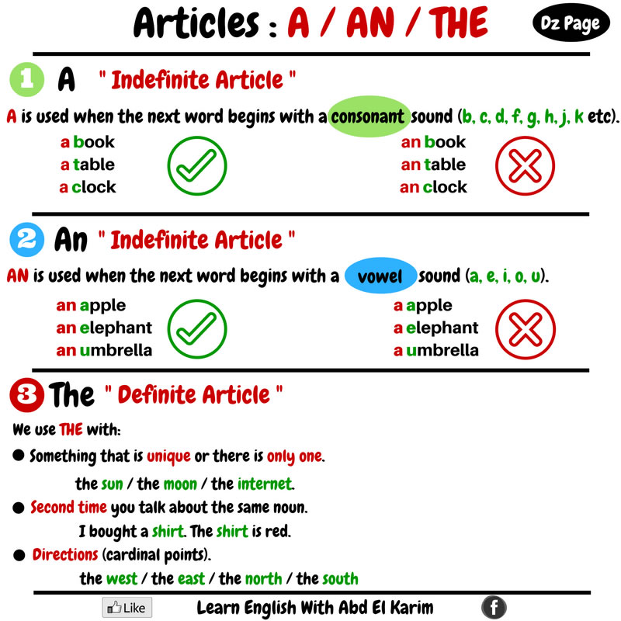

##### 定冠词the

<https://learnenglish.britishcouncil.org/english-grammar-reference/definite-article>

唯一(the moon)，形容词最高（the tallest），提过的指定（上下文），

表名词相关的群体（the wolf），乐器（the piano），表系统(the train,the bus),

表服务(the police) 表组织(the Seamen’s Union)

名字一般不用the，除非kingdom，states，republic，复数(the Netherlands)

地理特征(山脉，群岛，江河海运河)

著名的 报纸(The Times) 建筑(the empire state building) 艺术品(the Mona lisa)

##### 零冠词

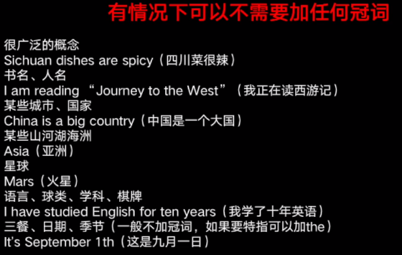

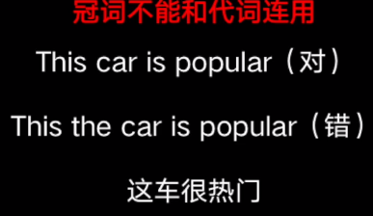

#### Noun

##### 分类

###### 专有名词、普通名词

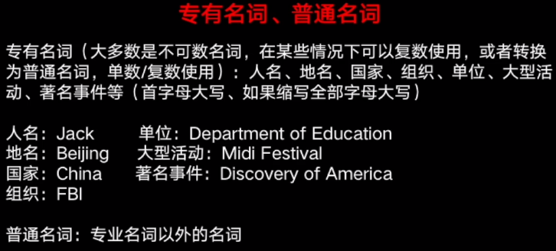

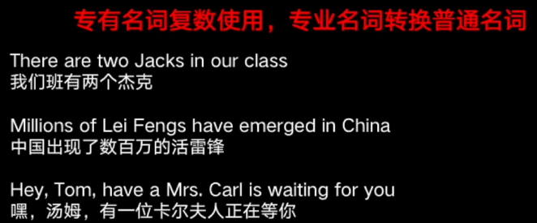

###### 不可数、可数

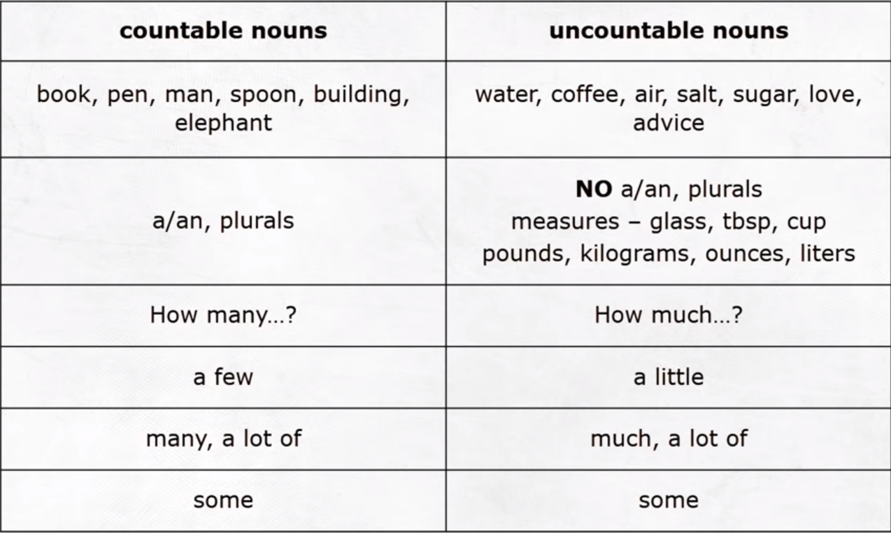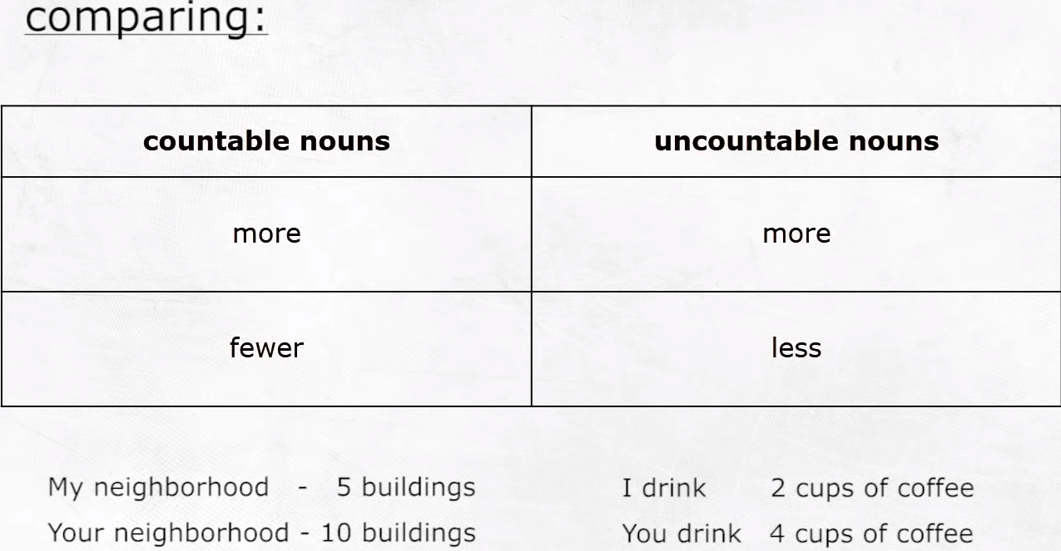

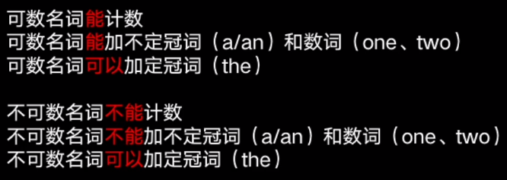

###### 抽象、具体

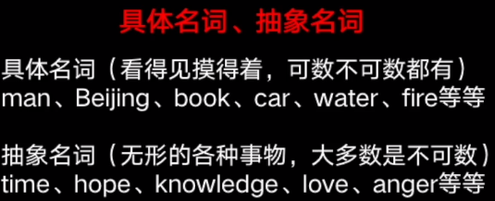

##### 单复数变换???

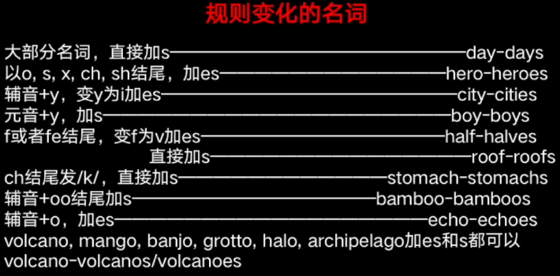 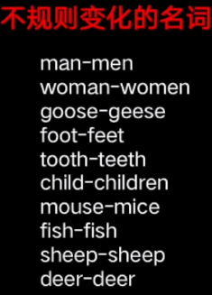

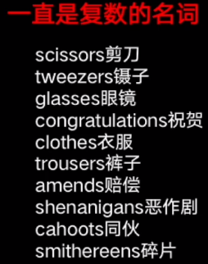 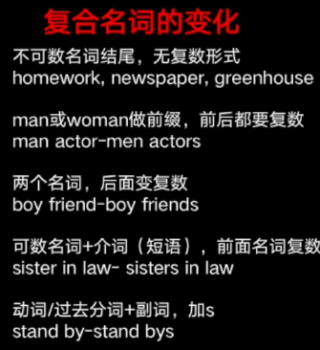

##### 所有格？？？？

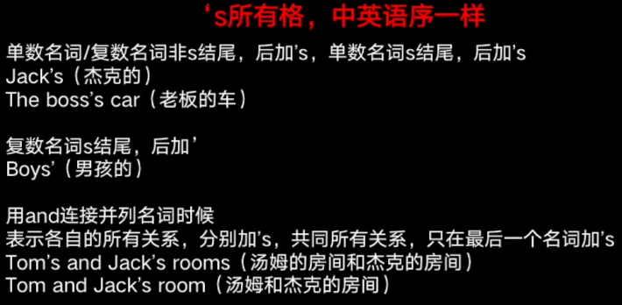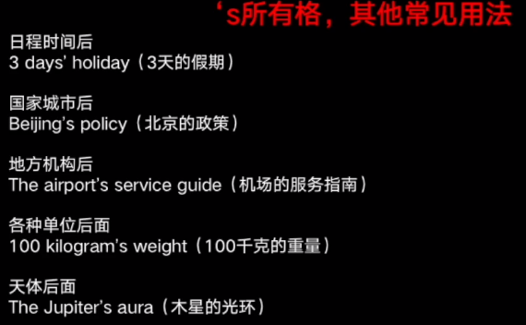

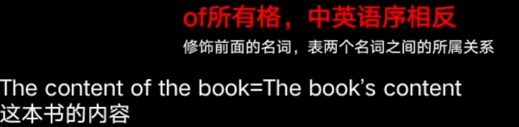

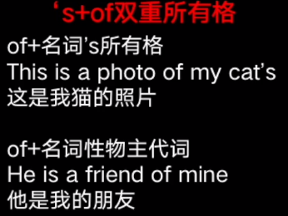

##### 主谓一致？？？？？

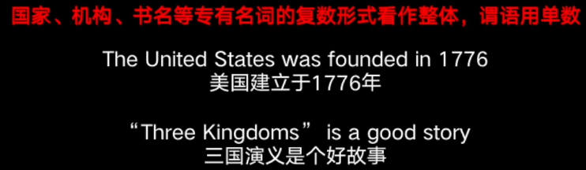

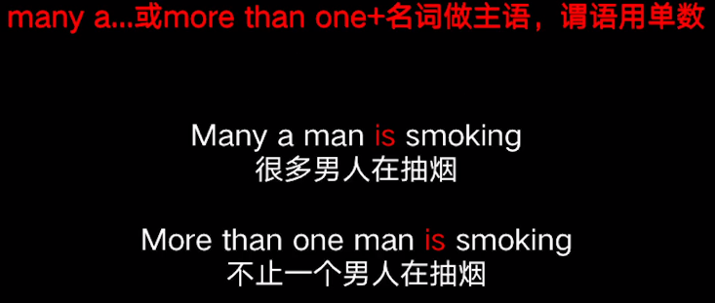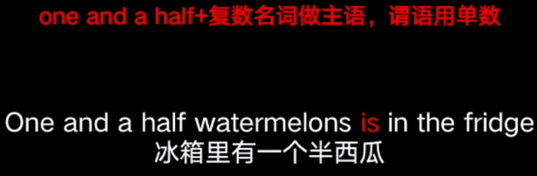

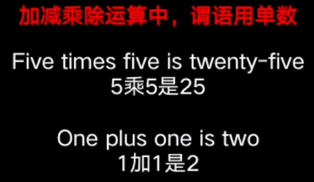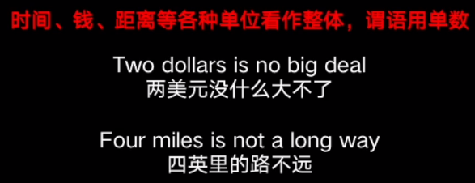

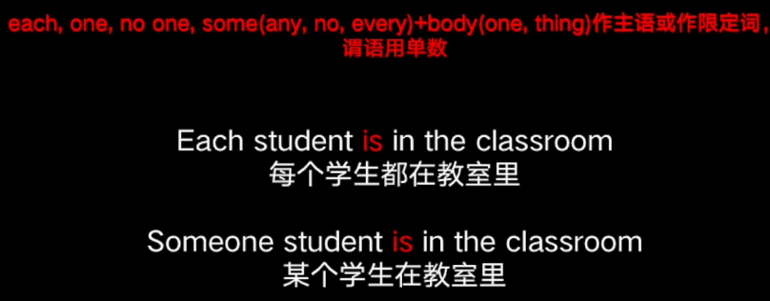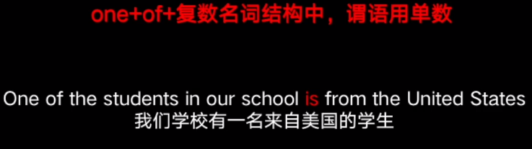

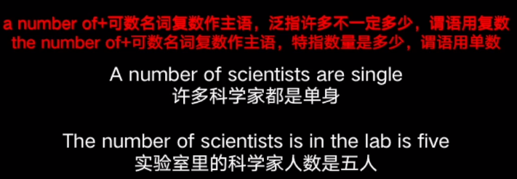

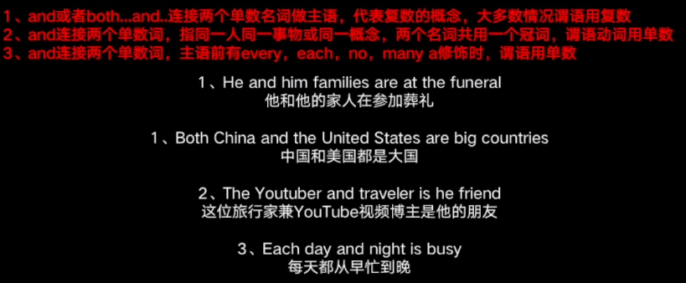

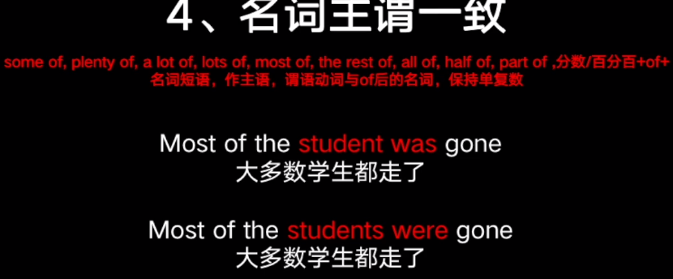

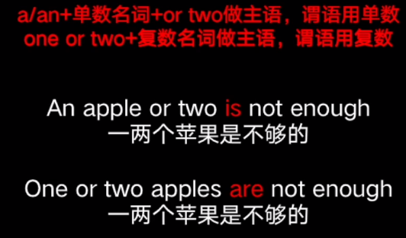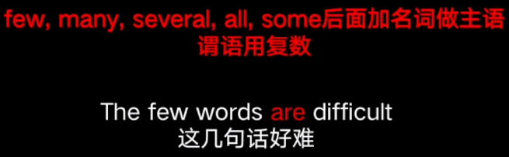

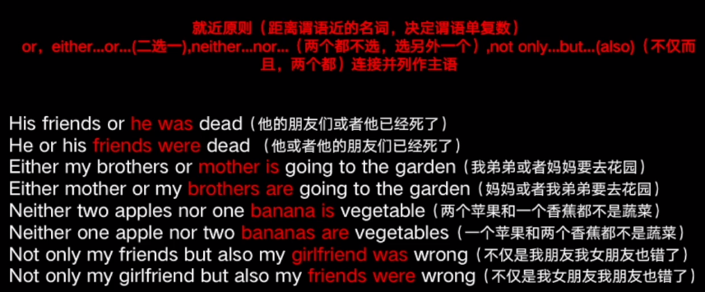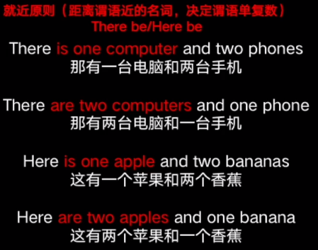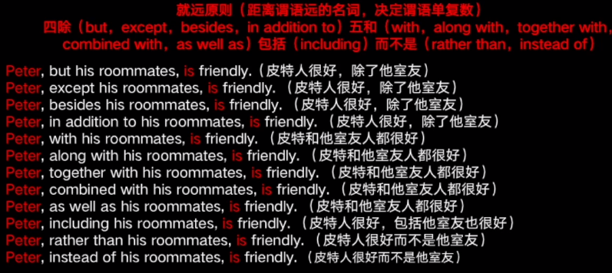

#### Pronoun

##### 人称代词

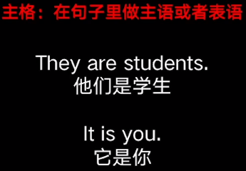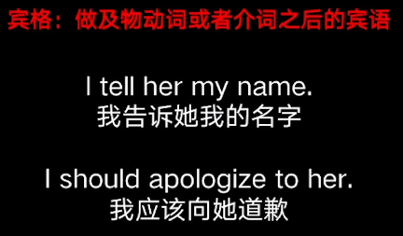

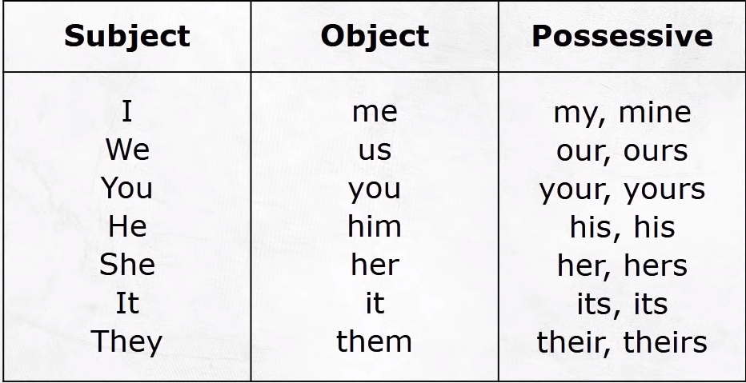

Paige and I work together。

The boss gave the project to Corey and me。

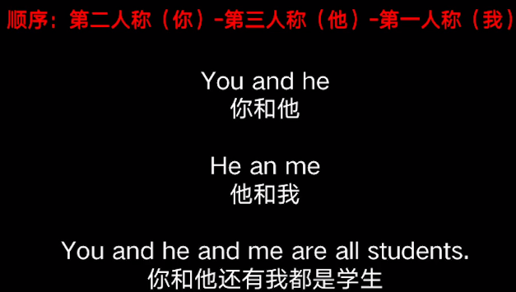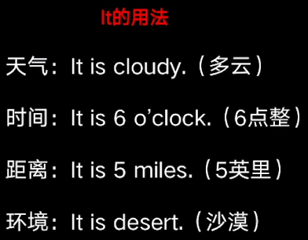

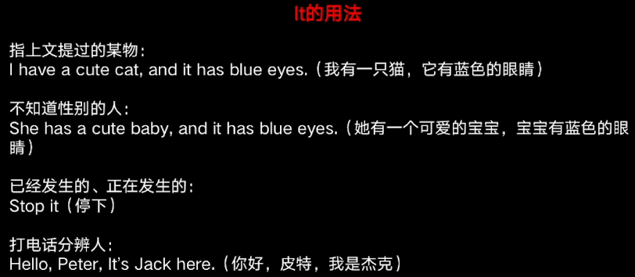

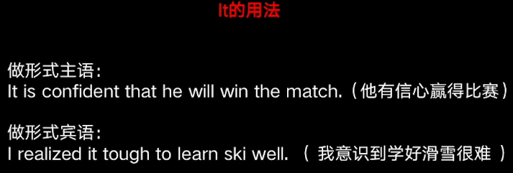

##### 物主代词

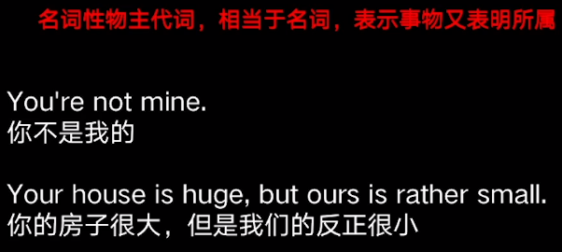

##### 反身代词

两代词指同一个

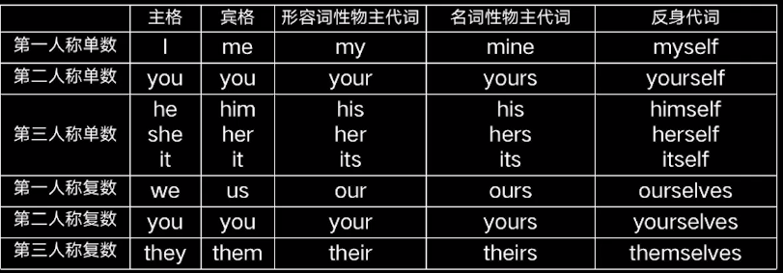

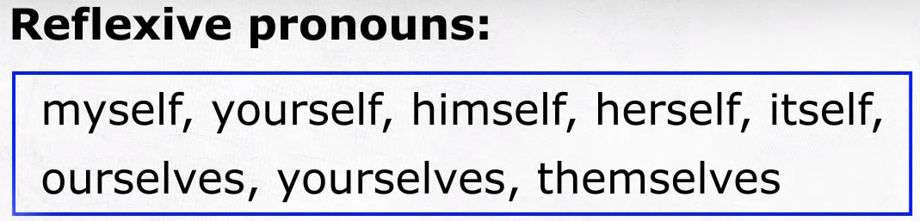

##### 指示代词

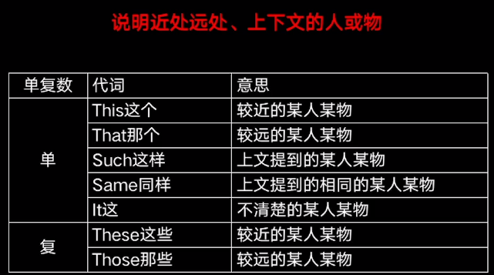

##### 不定代词

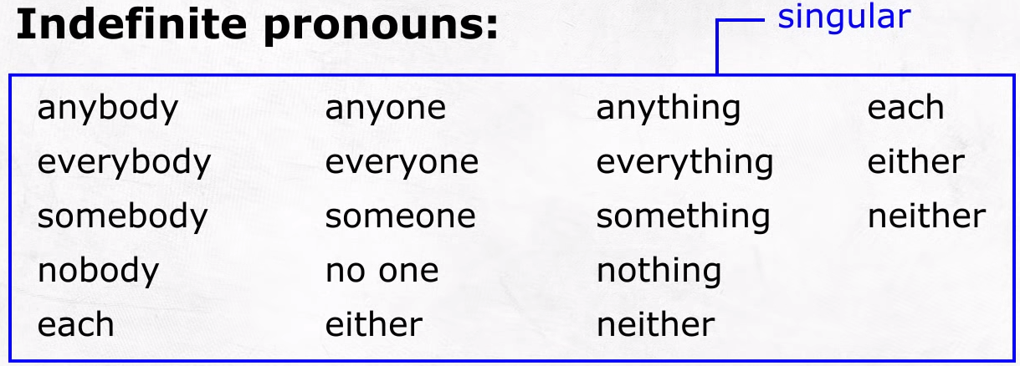

Neither of the two teams was able to score a goal

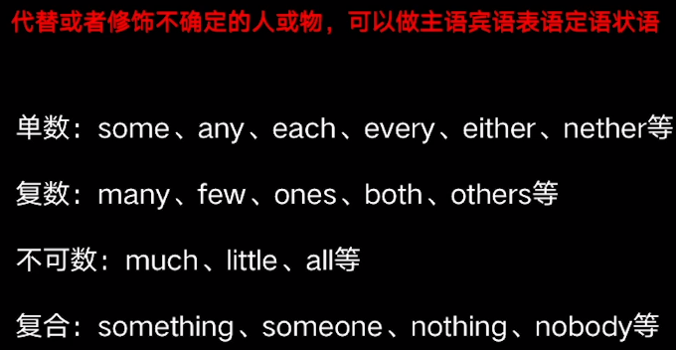

##### 疑问代词

who(subject pronoun) whom(object pronoun)

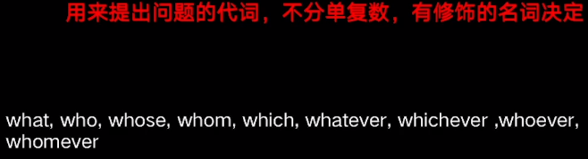

### 细节语法

#### have/has

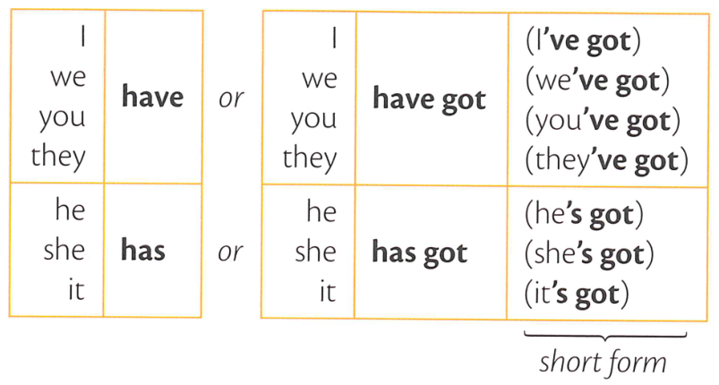

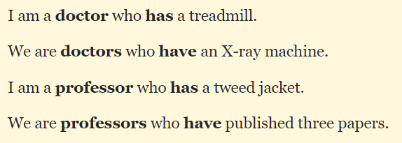

Singular subject always takes plural verb and plural subjects always take singular verbs.

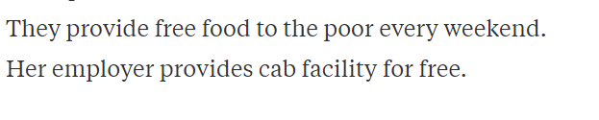

某事情过去被

was/were done

#### There have/has been

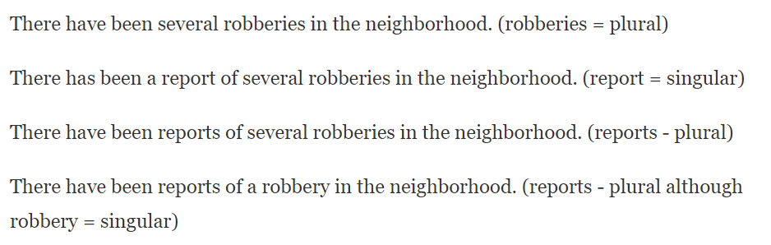

#### can could

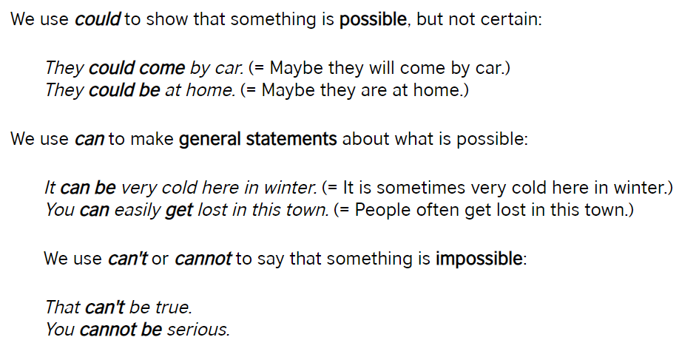

#### 时态表

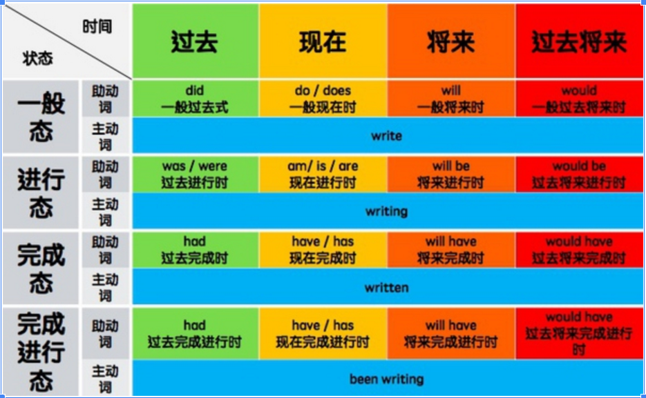。。。

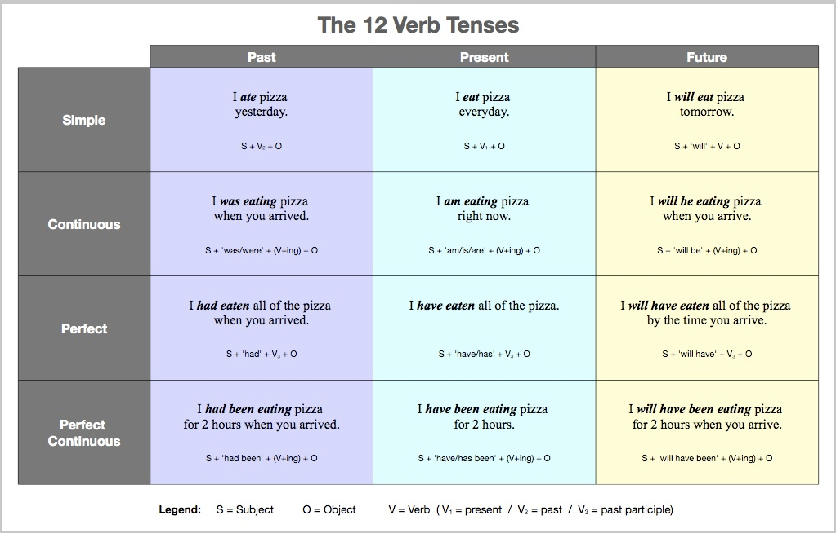

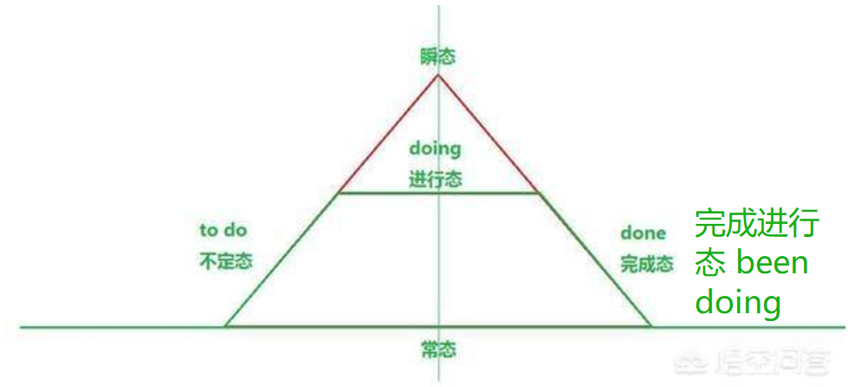

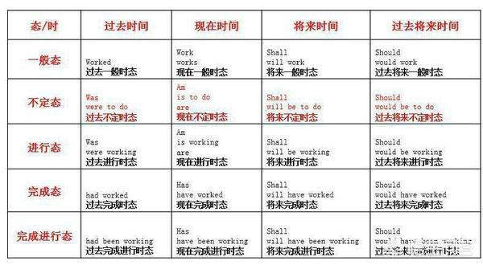

#### have/had done/have been doing

have done：站在现在时间点对过去动作的总结

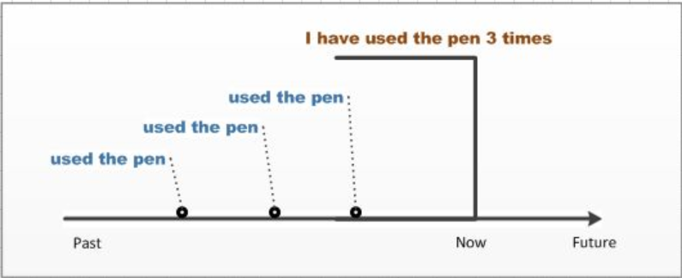

had done：站在过去某个时间点，对这个时间点之前发生动作的总结

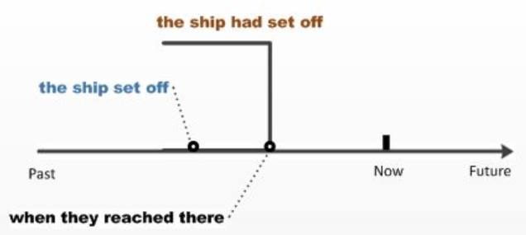

have been doing ：对现在正在进行动作的总结

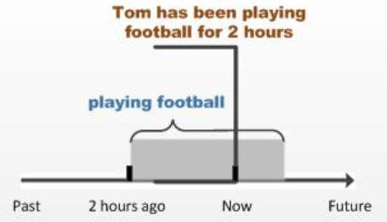

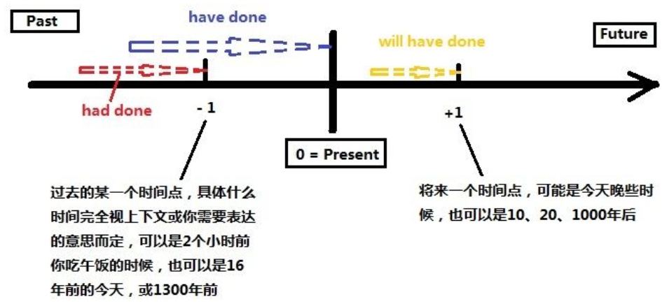

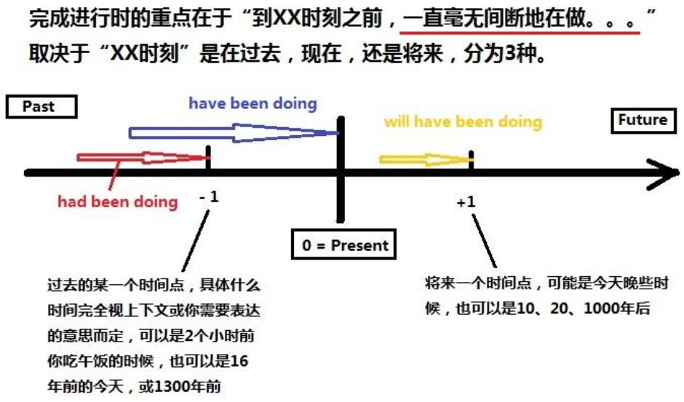

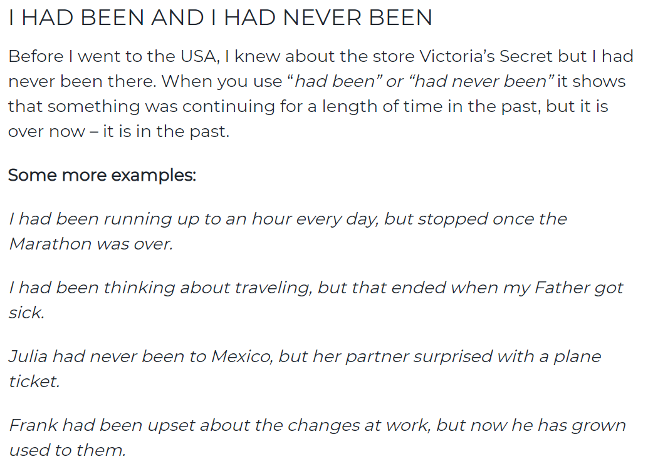

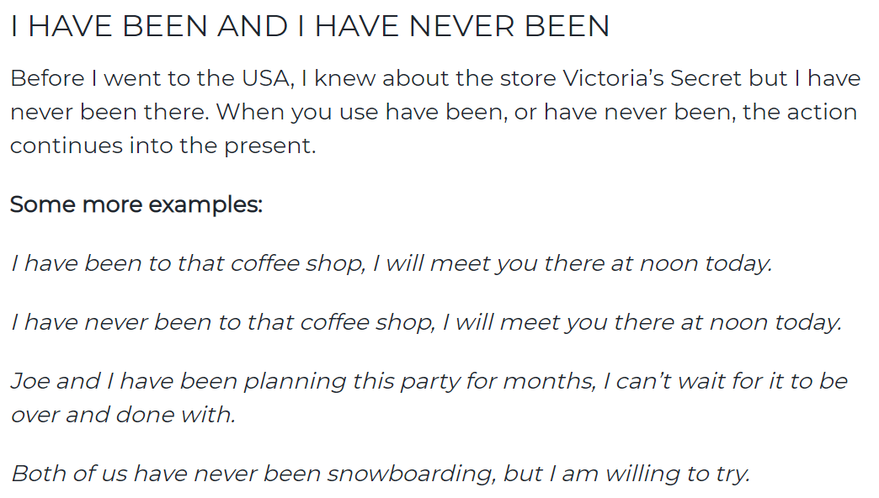

#### Could/should/would have done

可以，应该，想要做 但是实际上没有做

<https://www.perfect-english-grammar.com/could-have-should-have-would-have.html>

#### don’t，doesn’t

don't 是用于第一人称I ，we ，[第二人称](https://www.baidu.com/s?wd=%E7%AC%AC%E4%BA%8C%E4%BA%BA%E7%A7%B0&tn=SE_PcZhidaonwhc_ngpagmjz&rsv_dl=gh_pc_zhidao)you ，你，你们，和复数形式的they ，而doesn't 用于第三人称单数he ，she ，it 。他们都是用于一般现在时态的否定句中

#### affect vs effect

**Affect is usually a verb, and it means to impact or change. Effect is usually a noun, an effect is the result of a change.**

#### will vs would

<https://learnenglish.britishcouncil.org/english-grammar-reference/will-and-would>

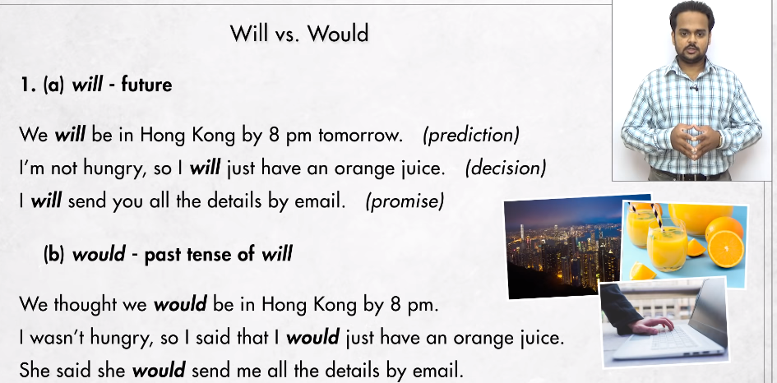

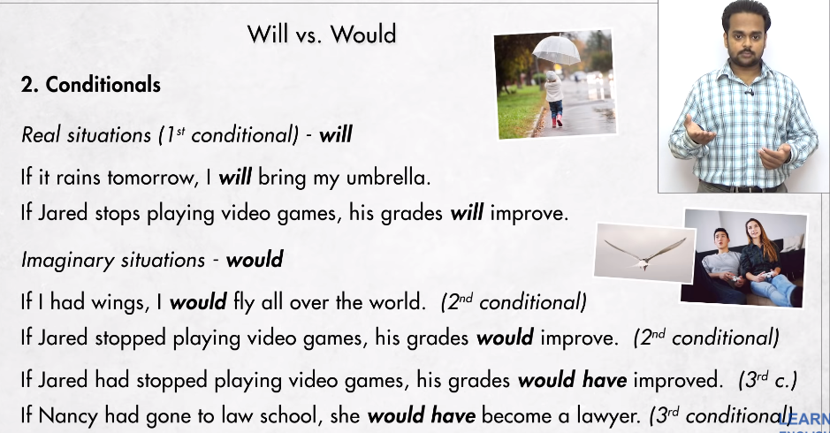

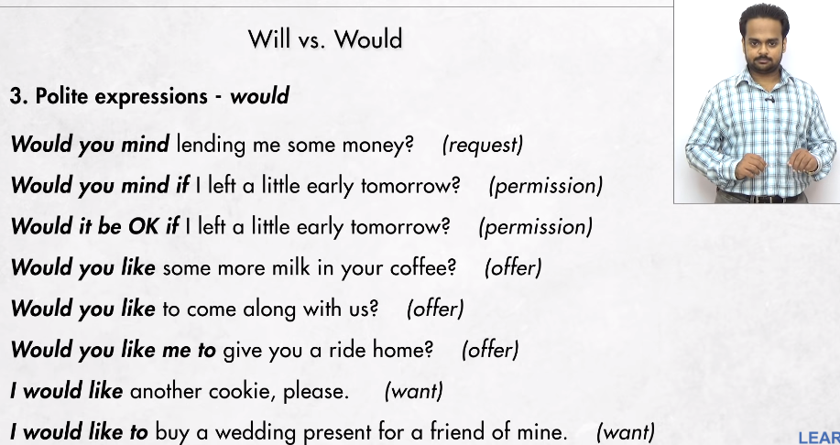

#### There is vs There are

过去式：there was vs there were



#### live life lives

live:过什么样的生活，生活在哪 live（发音不同）：现场 活的

life：陈述一种生活状态，方式

lives：生命

#### am is are was were

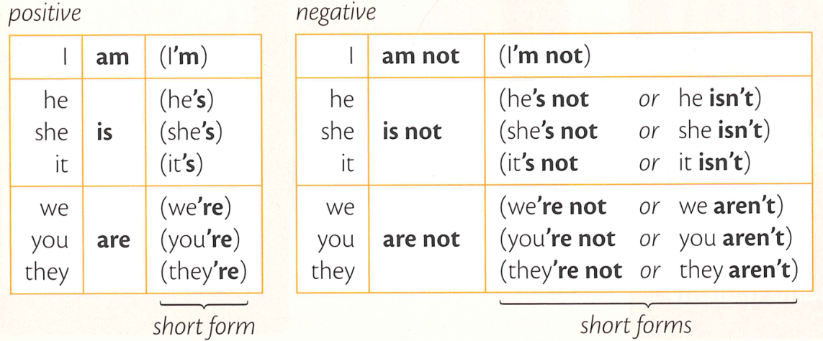

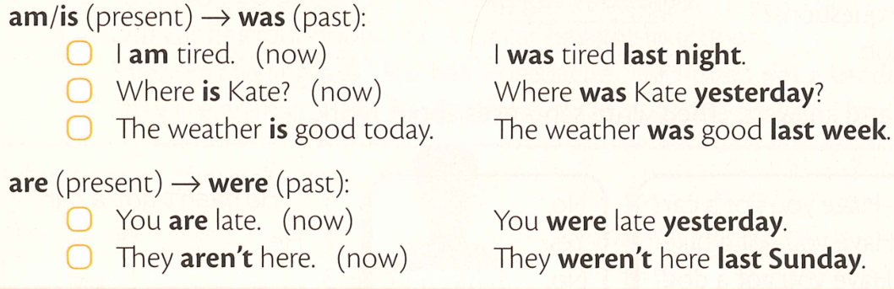

#### Do Does Did

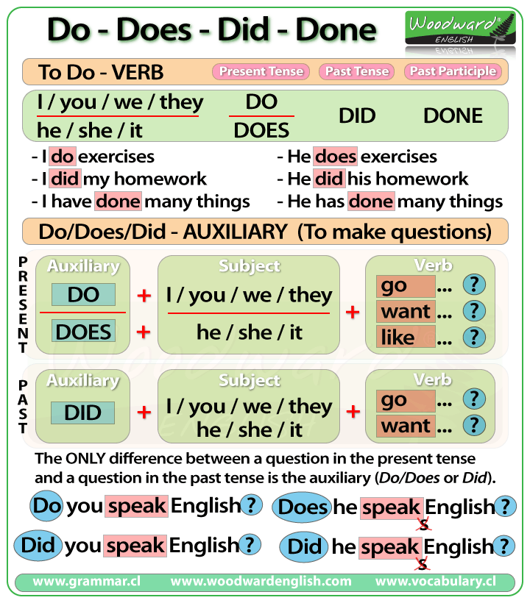

#### 主动词的过去式与完成态

过去式

一般+ed : work🡪 worked

以y结尾变ied : supply –>supplied

以p结尾+ped：step🡪 stepped 以n结尾+ned : plan🡪planned

不规则：

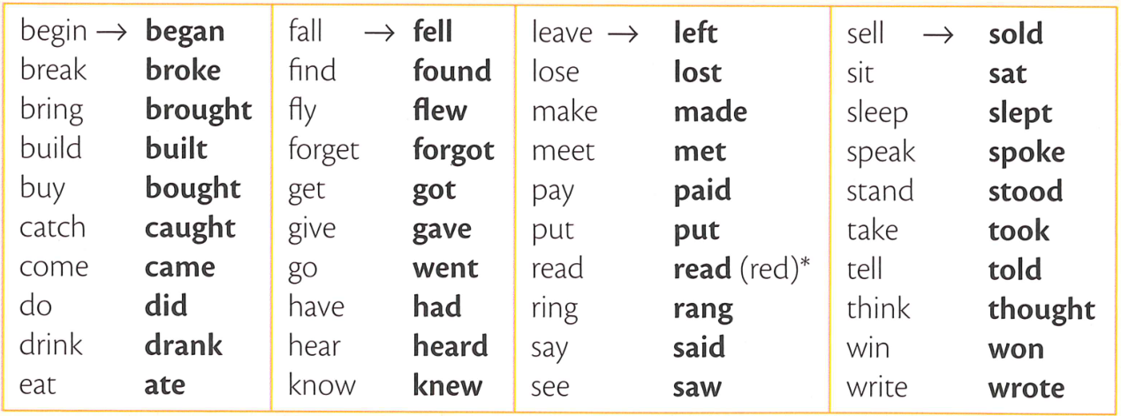

过去态

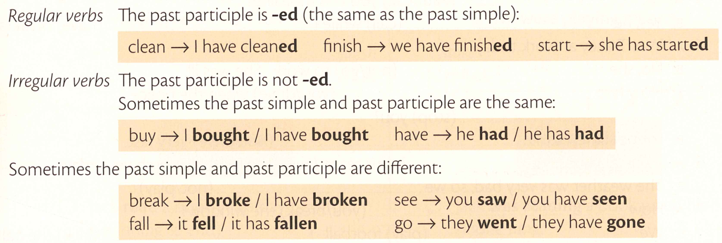

#### 系动词与助动词

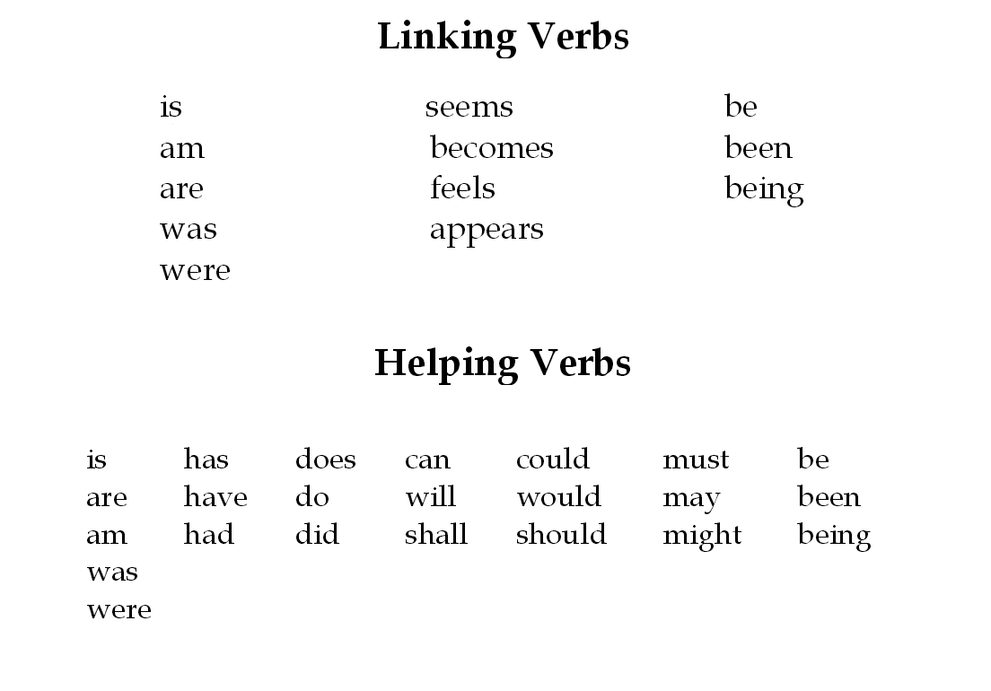

#### 动词

1. 助动词

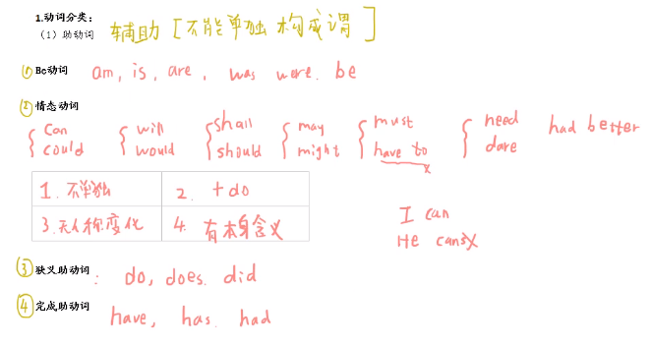

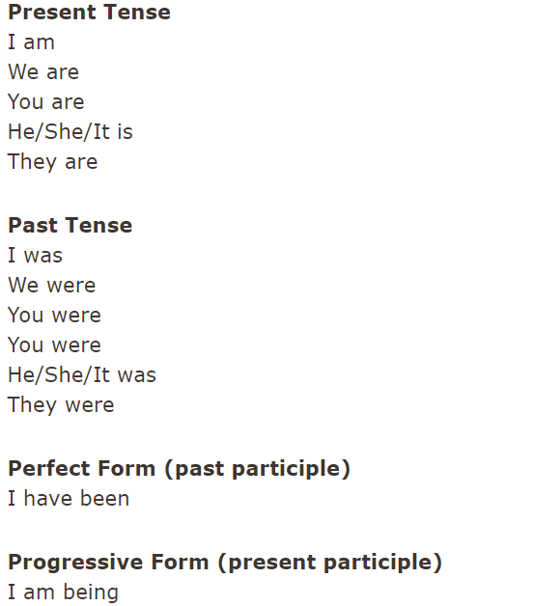

As a rule the word ‘been’ is always used after ‘have’ whereas ‘being’ is never used after ‘have’. It is used after ‘be’.

have been 表状态，have done 主动过去完成 have been done 被动过去完成

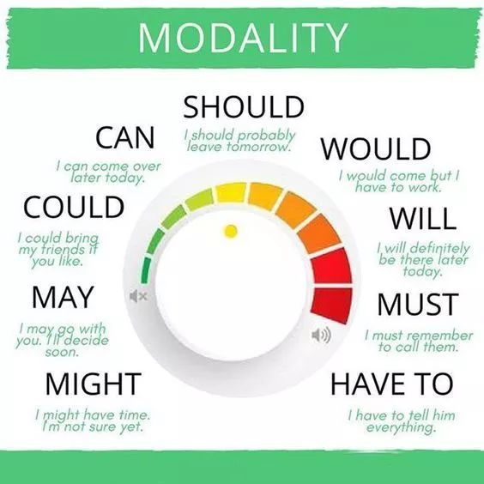 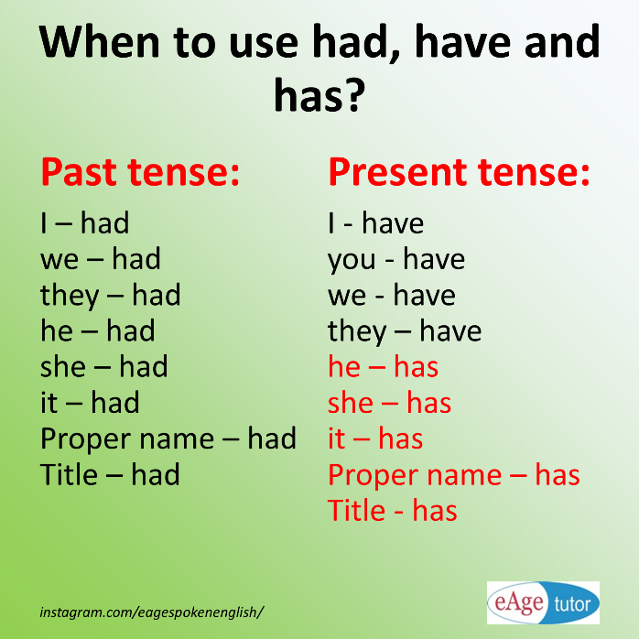

1. 实义动词

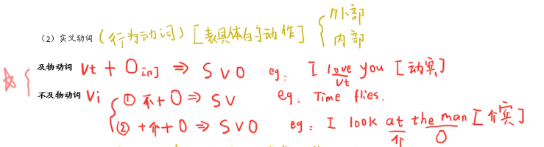

1. 系动词

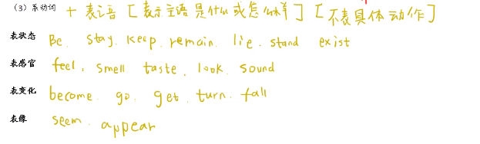

#### Be/Being/Been/to be

#### which,what

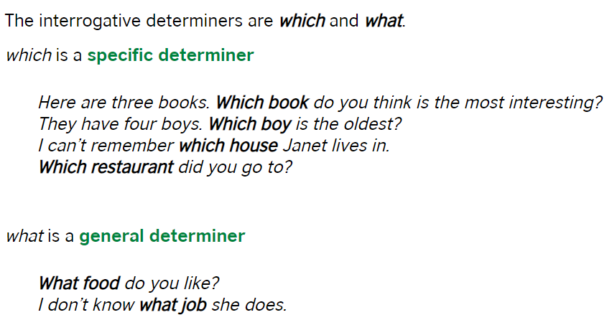

#### This/that,these/those

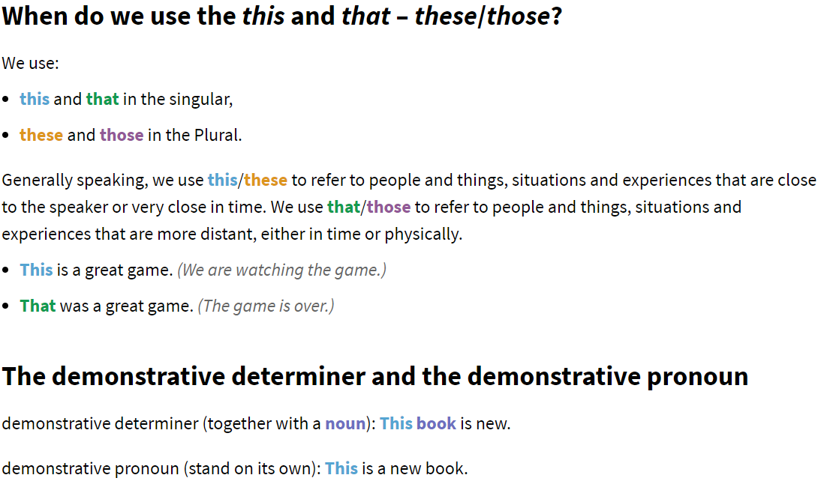

#### some vs any

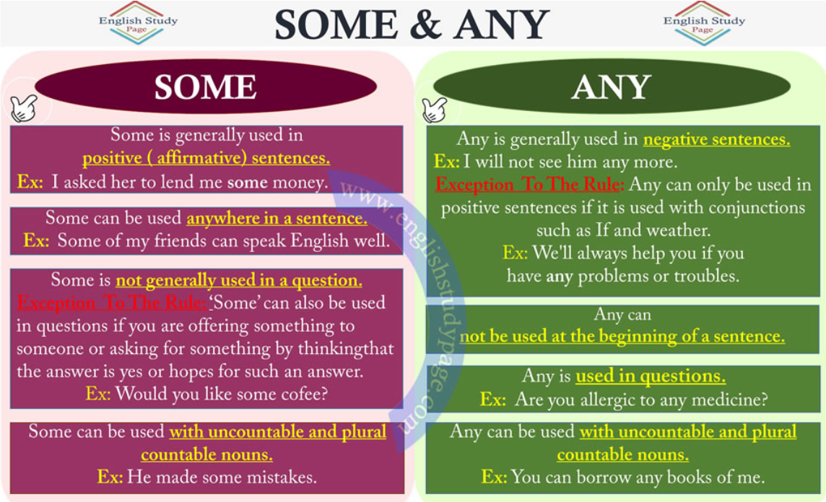

#### No，Not，None

<https://dictionary.cambridge.org/zhs/%E8%AF%AD%E6%B3%95/%E8%8B%B1%E5%BC%8F%E8%AF%AD%E6%B3%95/no-none-and-none-of>

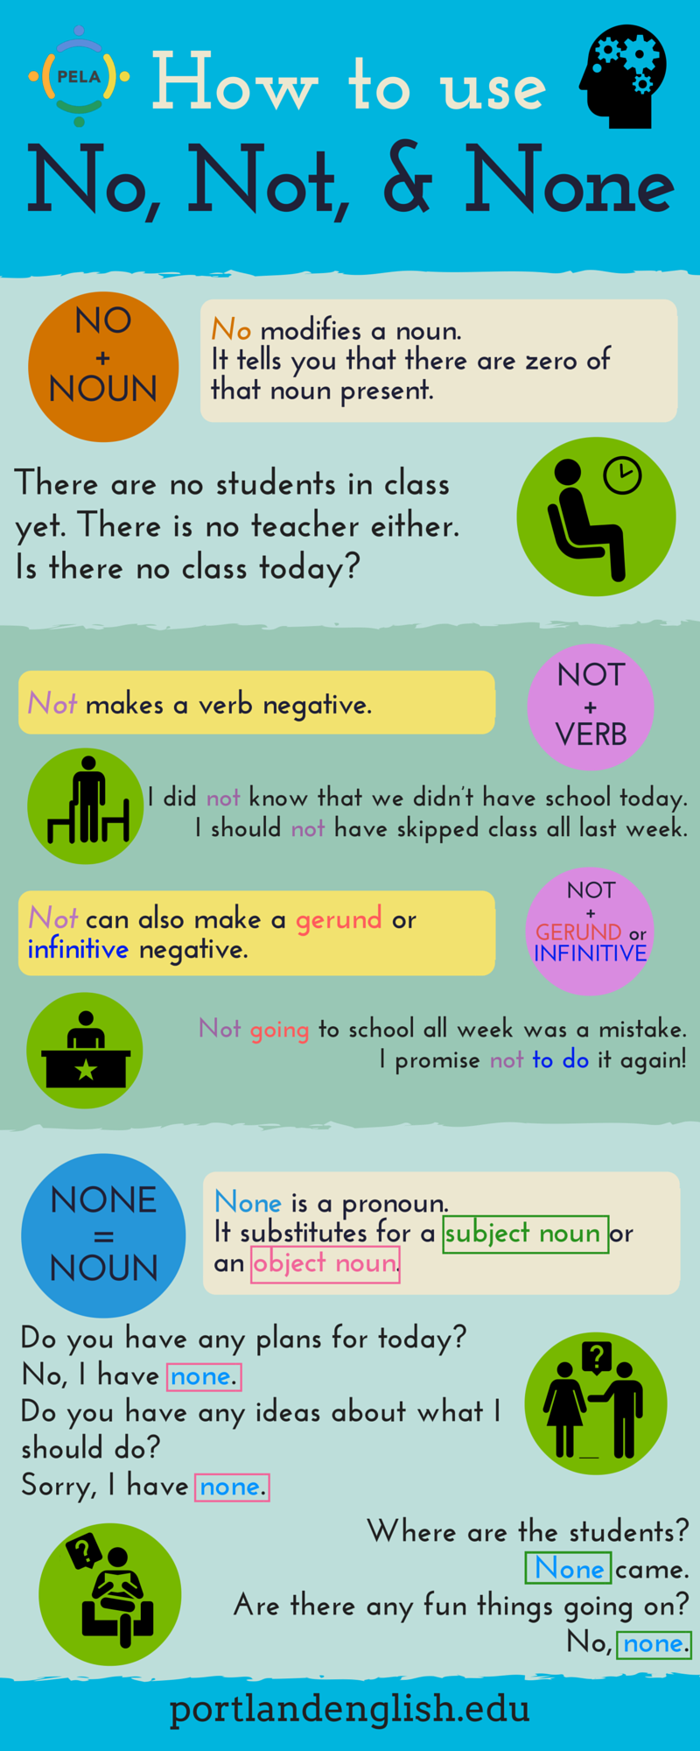

## 句型，短句

|  |  |  |  |
| --- | --- | --- | --- |
| 曾经 | | used to be | |
| A是有争议的 | | it’s debatable that A | |
| A需要 | | A involving | |
| 限量供应 | | limited range on offer | |
| 使A变得愉快 | | make A enjoyable | |
| 没有时间在一起 | | have litter time together | |
| A是正常的 | | it’s normal to see A | |
| 这样做的好处之一是 A | | one of benefit of this is A | |
| 没有时间做A | | leave no time for A | |
| 诱使A做B | | tempt A to do B | |
| 陷入 | | get into | |
| 不那么乏味 | | less tedious | |
| 对A有利，而对B不利 | | good for A but not for B | |
| 某些类型的 | | certain types of | |
| 至关重要 | | essential to | |
| 不应该成为A | | should no form part of A | |
| 能够获得 | | have access to | |
| 基本的 | | a basic level of | |
| 为其付费的人 | | who want to pay for | |
| 基础设施 | | infrastructure | |
| 由A进行 | | carried out by A | |
| 现在比过去多 | | more now than past | |
| 不得不更快去适应 | | have had to adapt to。。。more quickly | |
| 。。是不寻常的 | | it is unusual to find | |
| 我们深入了解 | | we gain insight into | |
|  | | opens our minds and makes us more tolerant | |
| 在一个国家定居 | | settle in a country | |
| 融入其中 | | to integrate | |
| 。。是。。的关键 | | 。。is key to。。 | |
| 保护。。避免 | | protect。。from。。 | |
| 关注 | | up-to-data with | |
| 主要原因 | | the major causes of this are | |
| 缺乏兴趣 | | a leak of interest in | |
| 因为 | | due to the fact that | |
| 了解 | | keep abreast of | |
| 以。。方式呈现。。 | | present。。in fromats that are | |
| 分发 | | be distributed to | |
| 几乎 | | at virtually | |
| 作用 | | the role of | |
| 确保公平 | | to ensure fairness | |
| 提出条件 | | imposing condition | |
| 方面 | | aspect of | |
| 应该改变 | | should be varied | |
| 取决于 | | depend on | |
| 排除 | | to exclude 。。out | |
| 不推荐 | | 。。is not to be recommended | |
| 很常见 | | it‘s quite common | |
| 很难判断 | | it‘s hard to judge | |
| 部分由于 | | so partly out of | |
| 解释为 | | be interpreted as | |
| 提出 | | raise | |
| 在许多方面 | | in many ways | |
| 作为 | | being a | |
| 适合所有人 | | suit everyone | |
| 花在（一直以来） | | is being spend on | |
| 。。的原因是 | | the reasons why。。are | |
| 解决 | | to solve\tackle | |
| 。。的主要原因之一 | | one of the main causes of | |
| 用。。手段控制。。 | | control 。。 with。。 | |
| 不止于此 | | dosen’t end there | |
| 助长 | | to fund | |
| 据说 | | said to be | |
| 榜样 | | role model | |
| 疏远 | | alienated from | |
| 最好方法 | | some of the best ways to。。 may be | |
| 提供资金 | | fund for | |
| 通过A用B解决C | | C can be solved through A by B | |
| 合适的方式 | | 。。is suitable way of。。 | |
| 更合适 | | 。。make。。more suitable for | |
| 提出 | | to setting out | |
| 官方投诉或法律事务 | | official complaints legal matters | |
| 自由选择 | | free to choose | |
| 决定接受 | | decide to under go | |
| 考虑 | | take into consideration | |
| 导致 | | result in | |
| 旨在 | | design to | |
| 通过。。创造。。 | | create。。through。。 | |
| 在。。情况下 | | in the event that | |
| 前所未有的风险 | | more at risk than ever before | |
| 因为A反对B | | Against A as B | |
| A不应该强制 | | A should not obligatory | |
| 有权选择 | | have right to choose | |
| 强烈认为 | | feel strongly | |
| 无疑 | | without doubt | |
|  | | whether 。。or not | |
| 看似合理 | | might seem sensible | |
| 将大部分A花在B | | spend a large part of A on B | |
| 可以说 | | It could be argued that | |
| 主要部分 | | as the main part of | |
| 给与补贴 | | offer subsidies to | |
| 买不起 | | cannot afford to buy | |
| 不是选择而是必须 | | not a choice but necessity | |
| A 似乎不是答案 | | A does not seem to be the answer | |
| 更艰难 | | faceing further hardship | |
| 充满A关于B | | full of A about B | |
| 看起来很自然 | | It seems natural that | |
| 也能 | | do manage to have | |
| 有时相反 | | sometimes the opposite is ture | |
| A的压力 | | the pressures of A | |
| 服药 | | taking drugs | |
| 因为A就诊 | | in clinics for A | |
| 不足以应对 | | not strong enough to deal with | |
| 可以说 | | it could be argued that | |
| A不太可能 | | it is unlikely that A | |
| 手工工作 | | manual jobs | |
| 需要的 | | what it entails | |
| 超过 | | rise above | |
| 没有A的人如何B | | How can a person without A to B | |
| 平衡预算，管理员工 | | balance a budget or manage staff | |
| 做明智的决定A | | make informad decision about A | |
| 有很多要学 | | has a great deal to learn | |
| 做手术 | | perform an operation | |
| 各个学科的学生 | | students from all disciplines | |
| 具有A进入工作市场 | | entering the job market with A | |
| 具有做A的资格 | | qualify them for A | |
| A的理论方面 | | theoretical side of A | |
| A 形成B的基础 | | A forms a basis for B | |
| 最后A | | ended up A，end up doing | |
| A是B的日常 | | A has become normal part of every day life for B | |
| 追随 | | to follow | |
| A与B保持联系 | | A keep in touch with B | |
| 谨慎使用A | | A should be used with caution | |
| 忽略事实A | | ignore the fact that A | |
| A有错误或偏见 | | A contain factual error or biased view | |
| 以平等的方式做A | | A on an equal footing | |
| 这是几年前难以想象的 | | in a way that was unimaginable a few years ago | |
| A 是做B的好方法 | | A is an excellent way to | |
| B取决于原因A | | B depends on the reason why | |
| B可以有一定的A | | B should be able to enjoy a certain amount of A | |
| 两者都不可少 | | neither A nor B is dispensable | |
| 依赖于A因为B | | rely on A for B | |
| 区分A和B | | to draw a distinction between A and B | |
| 尽可能变成A | | becoming as A as possible | |
| B注意力集中在A | | B to focus their attention on B | |
| 长途 | | traveling long distances | |
| 如何解决A | | how A can be overcome | |
| A对B不惊讶 | | A not be too surprised to B | |
| A是B的重要部分 | | A formed an important part of B | |
| A甚至不知道B | | A do not even know B | |
| 关于A的一些原因 | | There are some reasons why A | |
| B与A的关系变浅 | | A relationships with B to be more superficial | |
| 导致 | | lead to，result in，bring about，give rise to | |
| A与B的关系比C好 | | A forming close relationships with B than C | |
| 提高A | | A can be improved | |
| 相遇交友 | | meet and make friends | |
| 建立社区 | | from associations | |
| 定期讨论A | | meet regularly to discuss A | |
| A不如以前重要 | | A not important as it was in the past | |
| 有人说A | | some argue that A | |
| A拥有B | | A in possession of B | |
| A没有机会从B中受益 | | A with little opportunity to benefit from B | |
| A与B没有可比性因为C | | there is no comparison between A and B as C | |
| A能够受益于B | | A is able to benefit from B | |
| A使B走向巅峰 | | A have brought us to the peak of B | |
| 在各种行业的人 | | people in all walks of live | |
| 大型跨国公司 | | huge multinational companies | |
| 关于A的问题 | | the question of | |
| A是否有效是个备受争议的问题 | | whether A is effective or not is a hotly debated issue | |
| 损失是由A造成 | | damages is wrought by A | |
|  | |  | |
|  | |  | |
| 高看A | | places too much emphasis A | |
| A在B时无法想象 | A could not have been imagined in B | |
| A是错误的 | | it is a mistake to A | |
| 理解和处理A的知识 | | the knowledge to understand and deal with A | |
| A在B方面优秀 | | A is richer in B | |
| B的受害者A | | A become victims to B | |
| 随意开关A | | A that you can turn on and off at will | |
| 避免A骚扰B | | A should be prevented form harassing B | |
| 侵入 | | intrude into | |
| 禁止A做B | | A should be prevented from B | |
| 应该享有 A | | deserve A | |
| 实际上A | | It’s true that A | |
| 大量的A | | a multitude of A | |
| 表面上 | | On the face of it | |
| 幸运儿 | | fortunate one | |
| A对B有正面的刺激 | | A to play with stimulate many positives in B | |
| 接触A | | acquisition of A | |
| A设计的B | | A is designed to be B | |
| A对B有害 | | A could be in any way detrimental to B | |
| 隐藏陷阱 | | hidden pitfall | |
| C用A宠坏B 导致D | | C spoil B by A resulting in D | |
| A充满诱惑 | | A surrounded by too many tempting objects | |
| A遭B嫉妒 | | A become targets of envy from B | |
| 证明A对B有害 | | A proven to be dangerous for B | |
| A的许多责任之一是B | | one of the many duties of A is B | |
| A做明智的决定B | | A to make an informed choice about B | |
| 损失由A造成 | | damages is wrought by A | |
| A在B方面走的很远 | | A would go a long way towards B | |
| 面对A，B是无效的 | | A is irrelevant in the face of B | |
| 与B比A对C做出更多 | | A will do a lot more to C than if B | |
| A推动B | | A would be giiving B a boost | |
| A坚信B不能袖手旁观 | | A firmly believe that B connot sit back | |
| 我们必须各司其职 | | we must all play our part | |
| 报纸专栏 | | columns in newspapers | |
| A并不少见 | | it is not uncommon for A | |
| 证据显示A | | There is evidence that A | |
| 关于A的新闻 | | news coverage of A | |
| 人们担心A | | there is a concern about A | |
| 崇拜名人 | | cult of celebrity | |
| 获得宣传 | | receive publicity | |
| A渴望关注 | | A crave attention | |
| A将B视为正常 | | A come to see B as normal | |
| A以B为代价 | | A also be at the expense of B | |
| A对B有深远影响 | | A have a more profound effect on B | |
| A形成关于B的扭曲画面 | | A may be forming a very distorted picture of B | |
| A带来的后果之一是B | | One of the possible negative consequences of A is B | |
| A对B在C方面的负面影响 | | The negative influence of A on B can be seen in C. | |
| A在媒体中盛行 | | The prevalence of A in the mass media | |
| 教育A B | | A be taught to critically evaluate B | |
| A对B形成现实的看法 | | A can from a realistic view of B | |
| A担任管理职位 | | A is taking managerial positions | |
| A仍是事实 | | It’s still a fact that A | |
| A 由B主导 | | A dominated by B | |
| 强制配额 | | imposed quotas | |
| A 有权利选择B | | A have a right to choose B | |
| A短期甚至长期影响B | | A affect B in the short term and even long term | |
| 需要鼓励A从事B | | A need to be encourage to take B | |
| 渴望在A取得成绩 | | aspore to do well in A | |
| 我相信A | | It’s my belief that A | |
| A寻找漏洞解决B | | A will simply try to find loopholes to get around B | |
| 顶尖人士 | | those who deserve to be at the top | |
| A以B为代价 | | A at the expense of B | |
| A寻求解决问题的办法 | | A to look for a solution to the problem | |
| A提出投诉 | | there would be a number of complains from A | |
| 查看更具体的原因 | | looking at more specific causes of the problem | |
| 不许A做B | | A is not allowed to B | |
| A都不完美 | | none of A are perfect | |
| A和B共同努力解决C | | Only by a concerted effort by both A and B can C truly be resolved | |
| A在B受欢迎 | | A are admired throughout B | |
| A希望模仿B | | A want to emulate the way of B | |
| A不值得B地位 | | A are not deserving of B status | |
| A证明B的重要性 | | A demonstrate the importance of B | |
| 宝贵的人生课程 | | teaches valuable life lessons | |
| 努力达成目标 | | working hard to achieve a goal | |
| A达到一定程度的名气 | | A reach a level of fame | |
| A更关注B比C | | A focus more on B than C | |
| A有崇高社会地位 | | A are people who are held at a lofty place in the society | |
| A存在相当大的争议 | | there has been considerable debate over the role of A | |
| 文明社会 | | a civilized society | |
| 双方都有强烈证据 | | there are strong arguments on both sides | |
| A除了极端状况下应该被保护 | | A should be protected in all but extreme circumstances | |
| 社会各阶层 | | all levels in a society | |
| A在B时被推翻 | | A were toppled in B | |
| 扼杀言论自由 | | muzzle free speech | |
| A冒着B风险做C | | A do C run a risk of B | |
| 没有A就不可能B | | without A no B is possible | |
| 没有A，B毫无意义 | | without A B would have no meaning at all. | |
| 没有A，B是徒劳 | | without A it’s futile to expect B | |
| 对A而言B更具挑战性 | | It may be challenging for A to B | |
| A公之于世 | | A out into the open | |
| 长期看来A结果更具破坏性 | | the consequences of A are likely to be more damaging in the longer term | |
| A引起激烈辩论 | | A has triggered spirited debate | |
| A完全有能力B | | A are fully capable of B | |
| A让B感到羞愧 | | A really put B to shame | |
| A受到B敬佩 | | A admired by B | |
| 从开明的角度来看 | | from an enlightened standpoint | |
| A应当有权做B | | A should be granted the right to do B | |
| A是一个有争议的问题 | | A was a highly controversial issue | |
| 鉴于A的全面发展 | | In light of this sweeping prograss in gender equality | |
| A超出B的范围是没有依据的 | | A out of bounds of B is unwarranted | |
| 我一直相信A符合B的最佳利益 | | I have been convinced that it is in the best interest of B if A | |
| 世界时事 | | world current affairs | |
| A以B为特点 | | A that feature B | |
| A可以依靠B做C | | A should be able to rely on B for C | |
| A 是B样更容易接受 | | it’s more acceptable for A to B | |
| 免费宣传A | | giving free publicity to A | |
| A对耸人听闻的故事极其不满 | | Sensational stories cuase great unhappiness to A | |
| 杂志可以刊登关于A的文章 | | magazines can feature some articles on A | |
| A应该得到相应的奖励 | | A should therefore be rewarded accordingly | |
| A 很少见 | | A is seldom the case | |
| A的薪水和费用 | | salaries and fees commanded by A | |
| A似乎不公平 | | A dose not seem fair | |
| 顶尖人士 | | on top of that the number who | |
| A分摊到许多年 | | A has to be spread over many years | |
| 这些同样适用于A | | The same applies to company bosses | |
| 绩效相关的薪酬 | | performance related pay | |
| 当下流行A | | A is very much in vogue at the moment | |
| 根据A奖励B | | Rewarding A according to B | |
| A长期以来作为C的标准 | | A has long been used as a yardstick for C | |
| 多年的相关经验 | | years of relavant experience | |
| 在许多情况下A | | there are many cases where | |
| 形成一个循环 | | on-going cycle will develop | |
| A由独立机构评估 | | A assessed by independent review bodies | |
| A更多是障碍不是帮助 | | A are more of a hindrance than a help | |
| 一旦涉及到A | | once A is involved | |
| 容易出错 | | prone to errors | |
| 我看过的所有A | | In all A I’ve see | |
| 过度沉迷A | | over-enthusiastic of A | |
| 将A转移到B | | divert B from A | |
| A对B产生巨大进步 | | A have caused enormous improvements in B | |
| A对B带来深刻变化 | | A have brought about a profound change in B | |
| A确实利大于弊 | | There are definitely more good things than bad things about A | |
| 事情的真相是A | | the fact of the matter is | |
| 改变的是A | | what has changed is that A | |
| A不是什么新鲜事 | | A is nothing new | |
| A比以前有更多机会B | | A have lots more chances than they ever had before to do B | |
| A在某种程度上式正确的 | | A may be ture to some extent | |
| A有义务做B | | A is obliged to B | |
| 有时候说A使B更开放 | | It’s sometimes said that A is making B more open | |
| 我认为A | | I would argue that A | |
| 以下事实可以看出A | | A can be seen by the fact that | |
| A越来越依赖B | | A have become more dependent on B | |
| A使B更容易受到C的影响 | | A make B more vulnerable to C | |
| B可以享受A的好处而没有坏处 | | B could have the benefits of A without it’s disadvantages. | |
| 人才流失 | | brain drain | |
| 趋势将继续下去 | | the trend is set to continue | |
| 更广泛的就业选择 | | the wide choice of employment | |
| 随着技术时代的发展 | | as the technological age has advanced | |
| 经济全球化 | | the globalization of the world economy | |
| A是无法阻挡的 | | A cannot be stopped | |
| A管理起来可能很麻烦 | | A may be cumbersome to administer | |
| 可以尝试将A付诸实践 | | an attempt could be made to get A off the ground | |
| A已经开始发生 | | A has already begun to happen | |
| 应该去纠正这种不平衡 | | attempts should be made to redress the imbalance | |
| A归咎于B的传播 | | A can be blamed to the spread of B | |
| 从表面上看 | | on the surface | |
| A一如既然 | | A are as present as ever | |
| A不仅仅是B | | A is built on far more than B | |
| 仔细研究A | | look in detial at A | |
| A非常重视B | | A places a lot of value on B | |
| 我认为存在一些根深蒂固的差异 | | I would argue that there are still some very deep-rooted differences. | |
| A对B施加压力 | | A exert pressure on B | |
| A并不少见 | | It’s not uncommon for A | |
| A获得B | | A manage to abtain B | |
| A给B带来压力 | | A contributes to the pressure on B | |
| A用B使C过更平衡的生活 | | A can help C lead more balanced lives with B | |
| 合理的A | | a reasonable amount of A | |
| A,B共同负责这个问题 | | A and B should take join responsibility for this problem | |
| A占B很大一部分 | | A accounts for a large proportion of B | |
| 可以采取措施阻止A | | Measures could be taken to discourage B | |
| 向A提供补贴做B | | subsidies could be offered to A to B | |
| 个人可以真正发挥作用 | | individuals can make a real difference | |
| 由于A是问题的主要来源 | | since A are a major source of the problem | |
| A将会产生重大影响 | | A would have a great influence/impact | |
| A B C 的组合 | | a combination of A，B and C | |
| 在A中也很显然 | | it also evident among A | |
| 在A方面受到限制 | | restricted in terms of A | |
| 谋生 | | earning a living | |
| A使B在C方面更具优势 | | A giving B an advantage in terms of C | |
| 应对 | | coping with | |
| A肯定存在危险 | | there are certainly dangers in A | |
| 休假 | | take time off | |
| 重新适应A | | to readapt to A | |
| A可能认为B更好 | | A may think that it’s batter to B | |
| 我认为A今天可能性不大 | | I think A is less likely today | |
| 应该鼓励A开阔视野 | | A should be encouraged to broaden their horizons | |
| A何时可用 | | when A become avaliable | |
| 我们熟悉的A | | we are familiar with A | |
| 有不同的计划可以A | | There are different plans that A | |
| A让我们了解B | | A keep us informed about B | |
| A一直在变 | | A change all the time | |
| A 有用 | | A serve a useful purpose | |
| 由于A的不断关注 | | as a result of constant A attention | |
| A过着奢侈的生活，拥有B | | A live extravagant lifestyles with B | |
| 公众普及 | | public popularity | |
| A可能证明B是合理的 | | A may justify B | |
| A更重视B而不是C | | A places more value on B than on C | |
| A赚的钱 | | the amount of money A make | |
| 聚光灯下没有隐私 | | there is litter privacy out of spotlight | |
| A将失去B能力 | | A are going to lose ability to B | |
| A近几年在恶化 | | A have definitely deteriorated in recent years | |
| A以B闻名 | | A have a reputation for B | |
| 尽可能准确的呈现信息 | | presenting information as accurately as possible | |
| A为我们开辟了一个新世界B | | A has opened up a new world of B | |
| 我们不需再等待A | | we no longer have to wait for A | |
| A已经提高了B的水平 | | A has actually improved standards of B | |
| 过于依赖 | | to reliant on | |
| A充分利用B | | A have made good use of B | |
| 这里人们不愿使用A | | there has been a reluctance to use A | |
| 努力让A了解B的原因 | | strive to make A understand the reason for B | |
| A设法避免危害B | | A would manage to avert the dangers that are seriously threatening B | |
| 向A提供奖学金 | | scholarships should be made available to A | |
| A可以通过B来实现 | | A can be done by means of B | |
| 向A免费提供B | | make B free to A | |
| A是个很难解决的问题 | | A is a very difficult one to address | |
| 我们应该竭尽全力 | | we should make every effort to do so | |
| 越来越多的证据证明A正在失控 | | there is growing evidence that A is getting out of control | |
| A因B承受缓慢而痛苦的死亡 | | A suffer from slow and painful death from B | |
| 纳税人的钱 | | the taxpayer money | |
| A因B而生病 | | A become sick from B | |
| 没有确切的证据证明A发生 | | there is not conclusive evidence that A happens | |
| 两者之间存在联系 | | there are is a connection between two | |
| 对A收税 | | a heavy tax could be placed on A | |
| A似乎无可置疑 | | A seems beyond any reasonable doubt | |
| 更加详细的看A | | take a more detailed look at the causes of A | |
| 与A度过美好时光 | | spend quality time with A | |
| 远离A | | has been a move away from A | |
| A可能反过来导致B | | A may in turn lead to B | |
| 生活水平下降 | | there is a drop in living standards | |
| A要更加了解B | | A become more aware more aware of B | |
| 这种恶化趋势没有被逆转 | | this worsening trend is not reversed | |
| A对B产生负面影响 | | B can be negatively affected by A | |
| 往往 | | tend to be | |
| 过度曝光会导致A | | too much exposure can encourage A | |
| A无法代替B | | A no substitute for B | |
| A无法提供B | | B that cannot be provided by A | |
| A处于有利地位 | | A is in an advantageous position | |
| A的支持者认为 | | Proponents of A argue that | |
| A让B跟容易卷入C | | A could make it easier for B to get involved in C | |
| 总是可以 | | always paid for | |
| A 不会受到任何影响 | | A will not suffer in any way | |
| 相互关注 | | look out for each other | |
| A扎根于B | | A put down roots in B | |
| A不愿意参与B | | A not willing to get involved in B | |
| 遇到困难 | | going through a hard time | |
| A与B有同样的兴趣 | | B interests to be similar to A | |
| A将B传递给C | | A pass on B to C | |
| 实现A的信仰 | | to what A believe in | |
|  | |  | |
|  | |  | |
|  | |  | |
|  | |  | |
|  | |  | |
|  | |  | |
|  | |  | |
|  | |  | |
|  | |  | |